台南縣立歸仁國中九十九學年度第一學期 一年級第二次段考 英語科試題 【試題卷】
範圍: 第一冊 第三課至第五課 班 號 姓名

第一 ～ 六大題請將答案畫於答案卡上
一.【聽力測驗】聽CD，配合圖片選出最適當的答案 4%
1. 2.
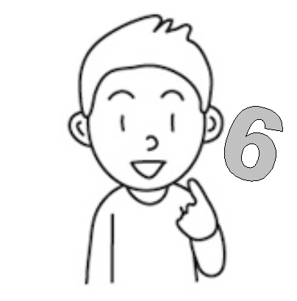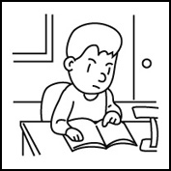
3. 4.
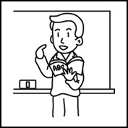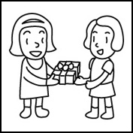
二.【聽力測驗】聽CD，選出最適當的答案 8%
5. (A) Clark is ten.
(B) Clark is not young.
(C) Clark is a young girl.
6. (A) Sally is not a singer.
(B) Sally is a good doctor.
(C) Sally is a beautiful singer.
7. (A) These students are thin.
(B) These students are short.
(C) These students aren’t thin.
8. (A) Andy is not from Canada.
(B) Andy’s friend is not from Canada.
(C) Andy and his friend are from Canada.
三.【聽力測驗】聽CD，符合各題敘述的選 A，否則選 B 8%
9. (A) True (B) False
10. (A) True (B) False
11. (A) True (B) False
12. (A) True (B) False

四、綜合測驗 40%
13. My puppy is fourteen years old. It’s not ______. It’s old.
(A) nice (B) young
(C) fan (D) hurry
14. Mr. Chen: _________ your books, students.
Students: Yes, Mr. Chen.
(A) Turn off (B) Stand up
(C) Open (D) Look
15. ________________ from Singapore.
(A) You and I are (B) I and you are
(C) You and she is (C) He and she is
16. 選出正確的句子
(A) Is that wonderful book, Johnny?
(B) My mom is the tall a woman.
(C) Hey! Janet’s classmate is pretty girl.
(D) Isn’t that a nice song?
17. Frank, _________ a good son!
(A) is (B) you
(C) are (D) be
18. Tina: How old is Peter and Linda’s brother?
Mary: _______________________
(A) He’s two-year-old.
(B) He’s one year old.
(C) They’re two years old.
(D) They’re one years old.
19. Andy’s computer is a tool ________ his homework.
(A) from (B) by
(C) for (D) with
20. That’s not your fault. _________ sorry.
(A) Be
(B) Don’t be
(C) Let’s not
(D) Don’t
21. The computer is great, but the salesmen ________.
(A) aren’t (B) are (C) isn’t (D) is
22. Father:________ is the talent show?
Son: It’s really special!
(A) How old (B) Why
(C) How (D) Where
23. Let’s ______________ in class.
(A) not talk (B) don’t talk
(C) talk not (D) be talk
24. _____________ young people from New Zealand?
(A) Is the (B) Is
(C) Are these (D) Are that
25. Joyce: Isn’t it his fault?
Allen: Of course not, _____________
(A) it is. (B) it’s his fault.
(C) it’s really a fault. (D) it’s my fault.
26. Don’t forget your _____________, young men.
(A) garbages (B) homeworks
(C) cellphones (D) moneys
27. Judy: Is ___________________?
Wendy: Yes, it’s heavy.
(A) a heavy box (B) a box heavy (C) it heavy box (D) the box heavy
28. Laura: Is your sister a good painter?
Ken: _______________________________
(A) No, she’s good.
(B) No, she’s a good sister.
(C) Yes, not really.
(D) Yes, she is.
29. Susan: Welcome to the party.
Bill: ____________________ party 派對
(A) Why? (B) Wow! How special!
(C) Come on! (D) I see.
30. Julia: Wait for me!
Dan: _____________________________
(A) That’s a good choice.
(B) Where are you from?
(C) Look here!
(D) Hurry! The show is on.
31. Pam: You’re really a wonderful cook!
Jerry: ____________________________
- Thanks. You’re also great.
- I’m so sorry.
(C) Come on! I’m a cooker.
(D) You’re right. That’s my fault.
32. Willy: Teddy’s brother is a composer.
Jane: ____________________________
Willy: He’s over there.
(A) How old is he?
(B) Where’s he from?
(C) Where’s he?
(D) How about your brother?
五. 克漏字測驗 10%
33~37題
Dear Grace,
This is a note (33) you. (34) the movie, Harry Potter and the Deathly Hallows, tomorrow. It’s (35) Harry, a boy (36) the UK. He’s a talented and special wizard. He’s cute, too. (37) the way, don’t forget to (38) your student ID card and the money. Anyway, just ___(39) __ .
Coco Wang

talented 有天分的; wizard 巫師; anyway 無論如何
33. (A) from (B) for
(C) at (D) of
34. (A) Let’s look (B) Let’s see
(C) Look at (D) Not see
35. (A) a (B) the
(C) about (D) from
36. (A) to (B) about
(C) for (D) from
37. (A) On (B) In
(C) From (D) By
38. (A) bring (B) leave
(C) forget (D) talk
39. (A) call the cellphone to me tonight
(B) call me the cellphone tonight
(C) tonight call to me
(D) call me tonight
40~42題
(On the phone)
Grace: Hey, Coco! I like your idea about the movie.
Coco: Really? Great! Harry Potter is _(40) .
Grace: Then, (41) 7:00 tomorrow evening?
Coco: OK! (42)
idea 點子; then 那麼
40. (A) favorite (B) his favorite
(C) I favorite (D) my favorite
41. (A) how about (B) how old
(C) where (D) why
42. (A) Just kidding!
(B) See you tonight!
(C) Welcome to the theater!
(D) Let’s have fun!

六. 閱讀測驗 5%
Nice to meet you! I’m Luke, an engineer from Australia. I’m 25 years old. I’m a music lover and a big fan of Lady Gaga. She’s young and beautiful. She’s a cool singer from the USA, and her songs are cool, too. For example, “Poker Face,” “Paparazzi,” and “Bad Romance” are very popular. I often watch Lady Gaga’s shows on TV. They’re really wonderful and special.
Are you also a “Gaga lover?”

for example 舉例來說; popular 流行的; often常常
43. Where is Lady Gaga from?
(A) South Africa (B) the USA
(C) Canada (D) Australia
44. Which isn’t Lady Gaga’s song? which 哪一個
(A) “Paparazzi” (B) “Bad Romance”
(C) “Doraemon” (D) “Poker Face”
45. Lady Gaga is ________________.
(A) a song (B) a singer
(C) a show (D) an engineer
46. Luke is ____________________.
(A) a music fan
(B) a lady
(B) a singer from Canada
(D) an engineer from Taiwan
45. Which is true?
(A) Lady Gaga is a music lover, but Luke isn’t.
(B) “Paparazzi” is a TV show.
(C) The engineer, Luke, is 25 years old.
(D) Luke is a young and beautiful singer.

