Flutter, flutter little bat, 旋律：小星星
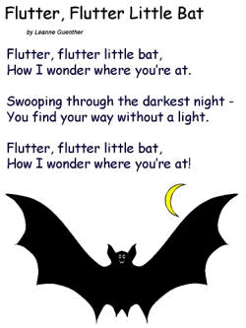
How I wonder where you’re at!
Swoopping through the darkest night,
How you find your way without a light!
Flutter, flutter little bat,
How I wonder where you’re at!
Vocabulary:

futter 拍動 How ( )
bat 蝙蝠
wonder懷疑 Where( )
swoop 俯衝
through通過
find找到
way路
without沒有
light光
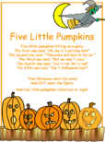
Five little pumpkins
Five little pumpkins sitting on a gate.
The first one said,”Oh my, it’s getting late.”
The second one said, “There are witches in the air.”
The third one said,”But we don’t care!”
The fourth one said,”Let’s run and run and run!”
The fifth one said,“We’re ready for some fun!”
Then OOOhh went the wind, and out went the lights,
And the five little pumpkins rolled out of sight.

Vocabulary:
sit 坐著 in the air 在空中 roll out of sight滾走消失不見
gate 大門 third第三個
first第一個 care在意
getting late越來越晚 fourth第四個
second第二個 fifth第五個
witch巫婆 wind風

