菁寮國小本土語言教學成果-結合社區資源拔蘿蔔
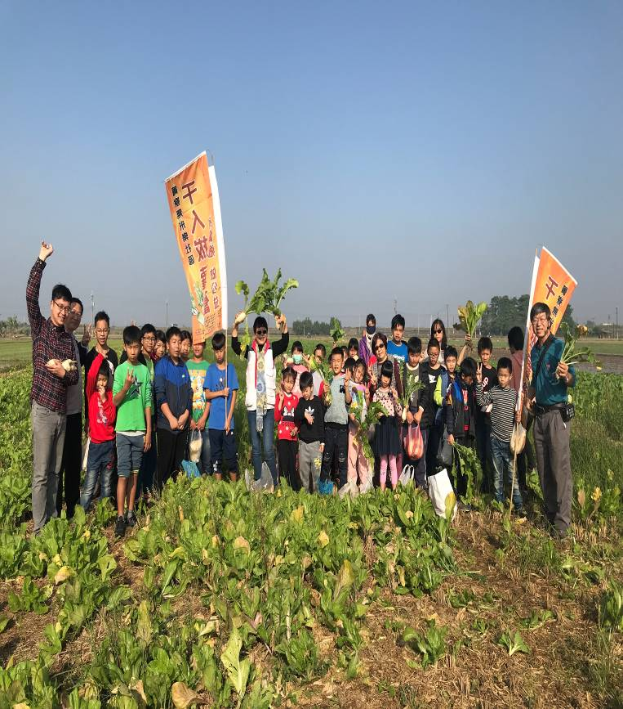 | 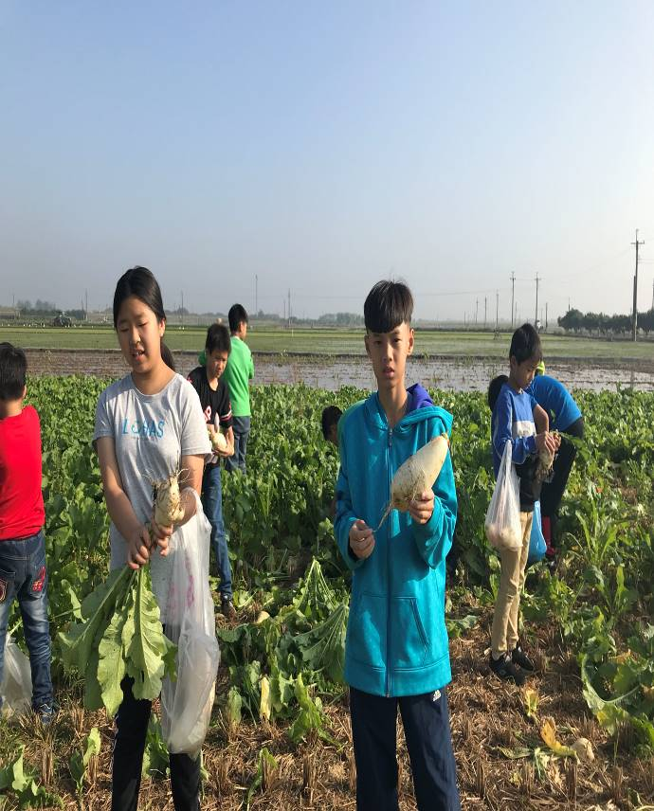
參觀蘿蔔田 | 體驗拔蘿蔔
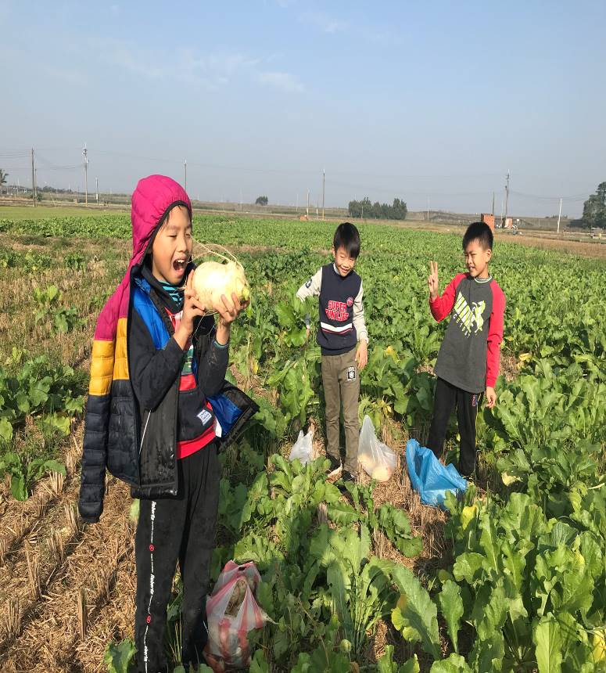 | 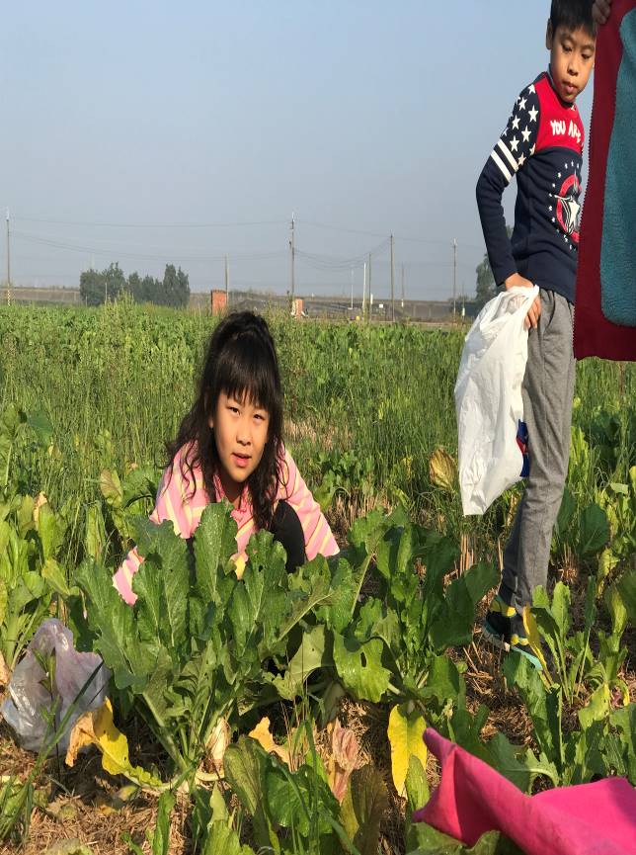
體驗拔蘿蔔 | 體驗拔蘿蔔
菁寮國小本土語言教學成果-結合社區資源拔蘿蔔

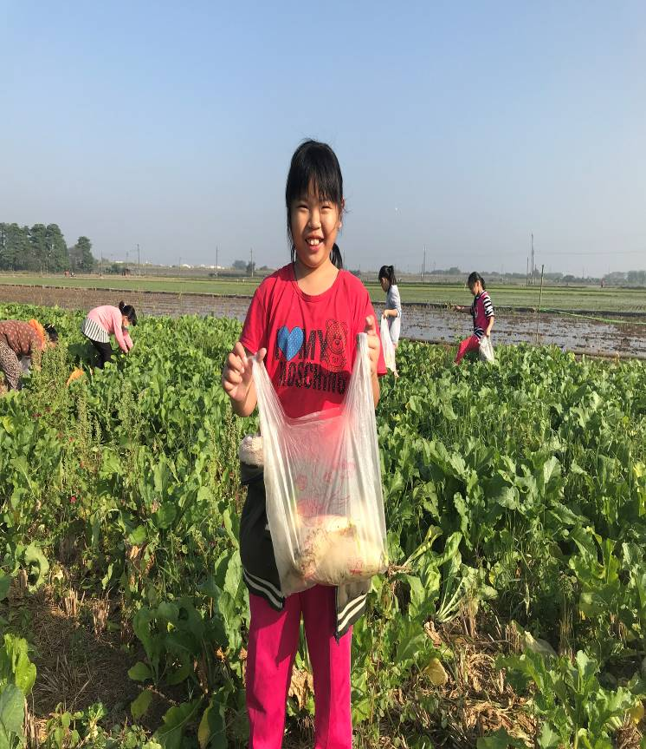 | 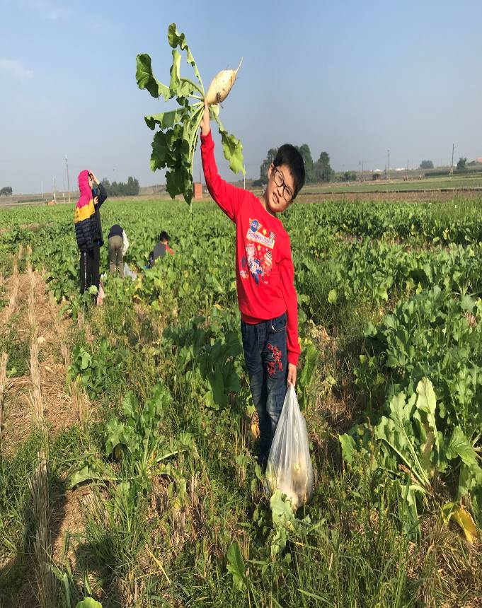
參觀蘿蔔田 | 體驗拔蘿蔔
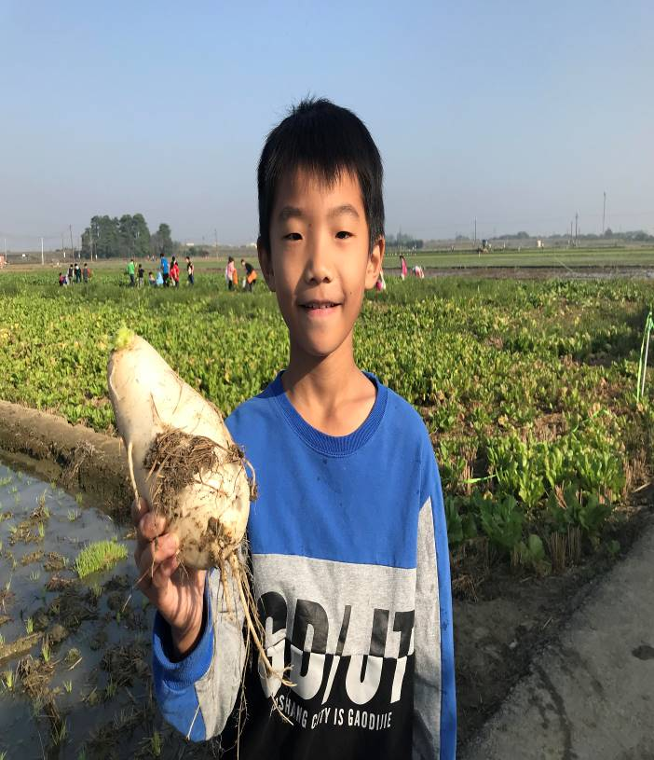 | 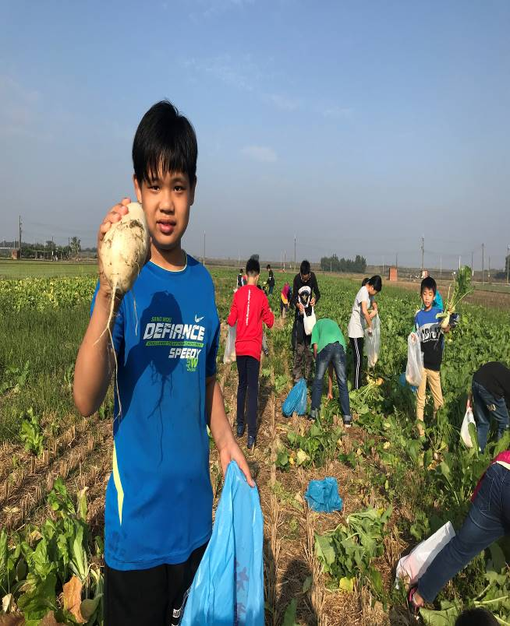
體驗拔蘿蔔 | 體驗拔蘿蔔

