二元搜尋法（Binary Search）
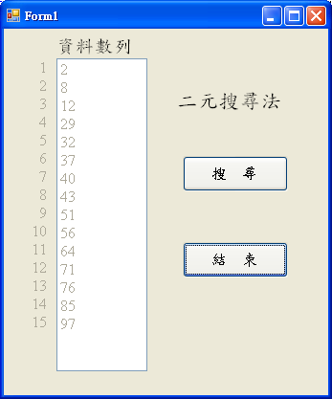
ListBox1
ListBox1
Button1
Button2
TextBox1
TextBox1屬性設定：
- BackColor = ButtonFace
- Enabled = False
- MultiLine = True
- TextAlign = Right

Public Class Form1
Dim Data As Short() = New Short() {2, 8, 12, 29, 32, 37, 40, 43, 51, 56, 64, 71, 76, 85, 97}
Private Sub Button1_Click(ByVal sender As System.Object, ByVal e As System.EventArgs) Handles Button1.Click
Dim L, R, M, Target As Short
Dim Result As Boolean
Target = Val(InputBox("請輸入搜尋值", "二元搜尋法"))
L = 0 : R = UBound(Data) : Result = False
While L <= R And Result = False
M = (L + R) \ 2
If Data(M) = Target Then
Result = True
Else
If Data(M) > Target Then
R = M – 1
Else
L = M + 1
End If
End If
End While
If Result Then
MsgBox(Target & "，在第" & M + 1 & "個位置", , "二元搜尋法")
Else
MsgBox("找不到" & Target, , "二元搜尋法")
End If
End Sub
Private Sub Form1_Load(ByVal sender As Object, ByVal e As System.EventArgs) Handles Me.Load
Dim I As Short
For I = 0 To UBound(Data)
ListBox1.Items.Add(Data(I))
Next
End Sub
Private Sub Button2_Click(ByVal sender As System.Object, ByVal e As System.EventArgs) Handles Button2.Click
End
End Sub
End Class

