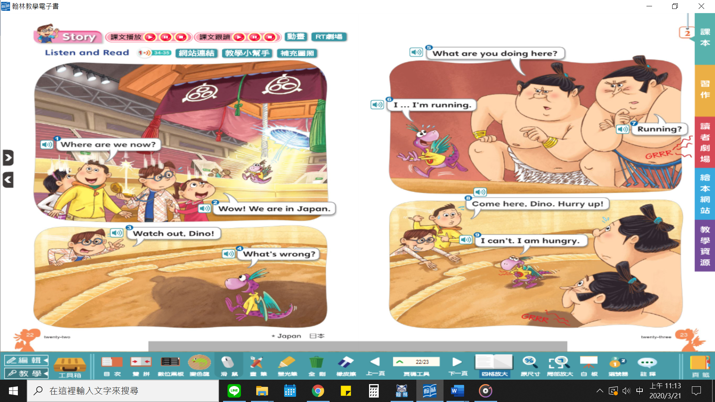
- Owen: Where are we now?  - Niki: Wow! We are in Japan.  - Danny: Watch out, Dino!  - Dino: What’s wrong?  - Sumo wrestler 1: What are you doing here?  - Dino: I… I’m running.  - Sumo wrestler 2: Running?  - Owen: Come here, Dino. Hurry up!  - Dino: I can’t. I am hungry. | Owen: 我們現在在哪裡？  Niki: 哇！我們在日本。  Danny: Dino，小心！  Dino: 怎麼了？  Sumo wrestler 1: 你在這裡做什麼？  Dino: 我……我正在跑步。  Sumo wrestler 2: 跑步？  Owen: Dino，過來這裡。快一點！  Dino: 我不能。我好餓。
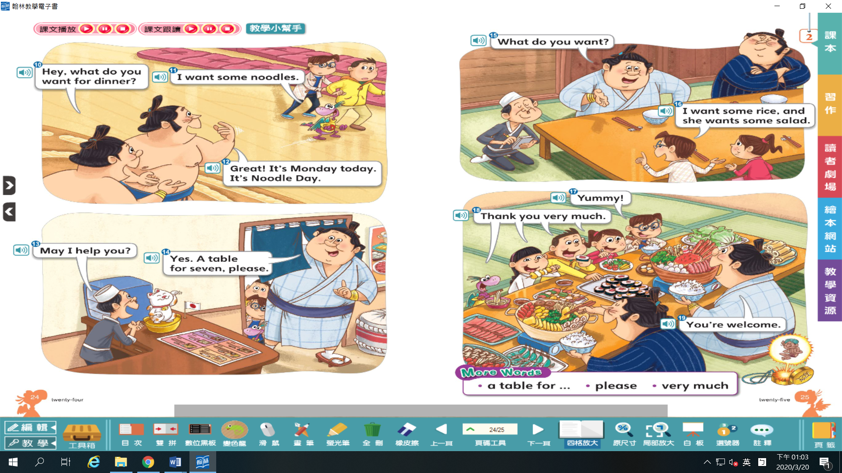
- Sumo wrestler 1: Hey, what do you want for dinner?  - Dino: I want some noodles.  - Sumo wrestler 2: Great. It’s Monday today. It’s Noodle day.  - Boss: May I help you?  - Sumo wrestler 1: Yes. A table for seven, please.  - Sumo wrestler 1: What do you want?  - Danny: I want some rice, and she wants some salad.  - Danny: Yummy!  - Dino, Irene, Owen, and Niki: Thank you very much.  - Sumo wrestler 1: You’re welcome. | Sumo wrestler 1: 嘿，你們晚餐想要吃什麼？  Dino: 我想要吃麵。  Sumo wrestler 2: 太好了！今天星期一。今天是吃麵的日子。  Boss: 我能幫您的忙嗎？  Sumo wrestler 1: 是的。請給我一張七人桌。  Sumo wrestler 1: 你們想要吃什麼？  Danny: 我想要吃飯，而她想要沙拉。  Danny: 真好吃！  Dino, Irene, Owen & Niki: 非常謝謝你們。  Sumo wrestler 1: 不用客氣。
應用字彙
breakfast 早餐 lunch 午餐 dinner 晚餐 a hamburger 漢堡 noodle(s) 麵條（常用複數） rice 米飯；稻米 salad 沙拉 soup 湯
does （助動詞，第三人稱單數時用） please 請 a table for… 給……（數量）人的桌子 very much 非常地
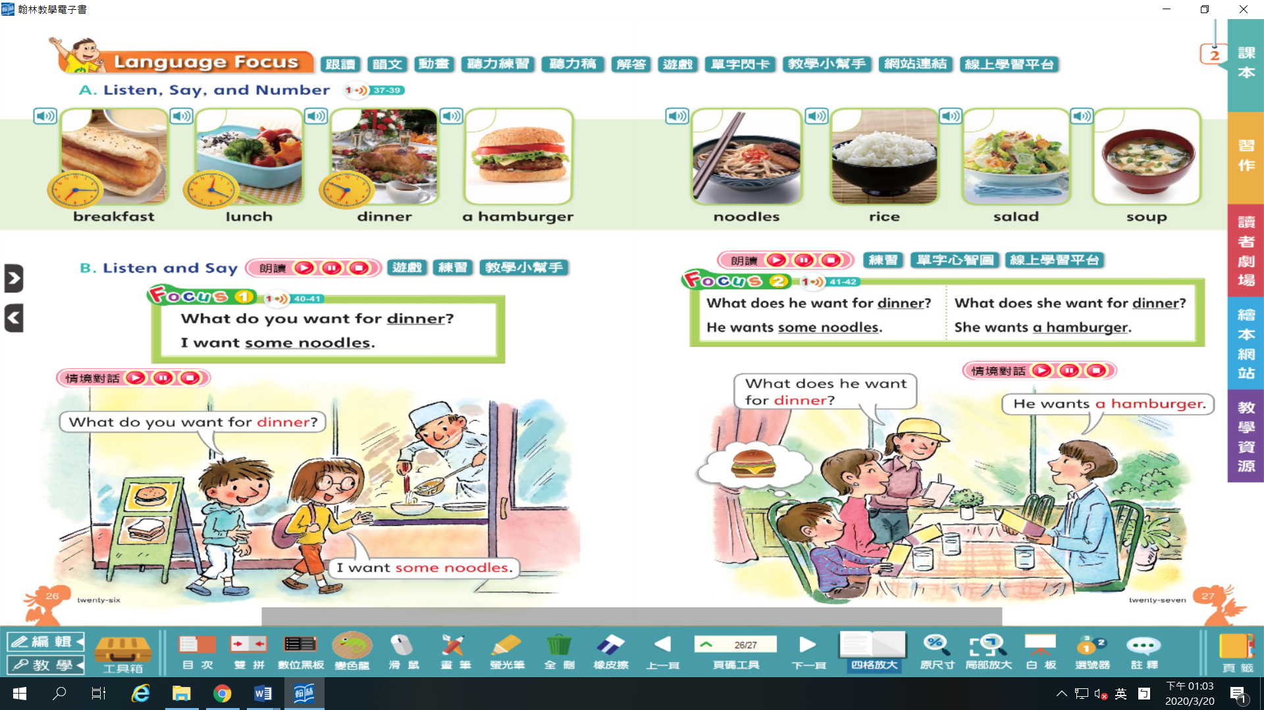

English | 中文
Chankonabe (Sumo Stew) | 相撲鍋
Chankonabe is a Japanese stew.  It’s a stew with lots of chicken, fish, tofu, and vegetables in a hot pot. | 相撲鍋是日本鍋物料理。  在火鍋裡放了大量雞肉、魚肉、豆腐和蔬菜的燉菜。
In Japan, a sumo wrestler can eat a big chankonabe with lots of rice! | 在日本，相撲力士可以吃完一大份的相撲鍋，並配上大量白飯。
Sumo wrestlers like chicken because chickens stand on two feet like a good sumo wrestler. | 相撲力士喜食雞肉，因為雞隻以雙腳站立不倒的樣子就像厲害的相撲力士。
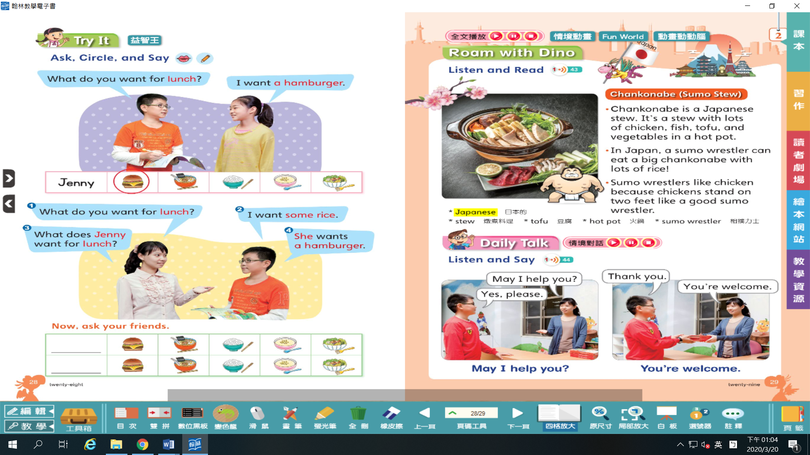

音韻字彙
bike 腳踏車 kite 風箏 pie 派；餡餅 tie 領帶 fly 飛 sky 天空

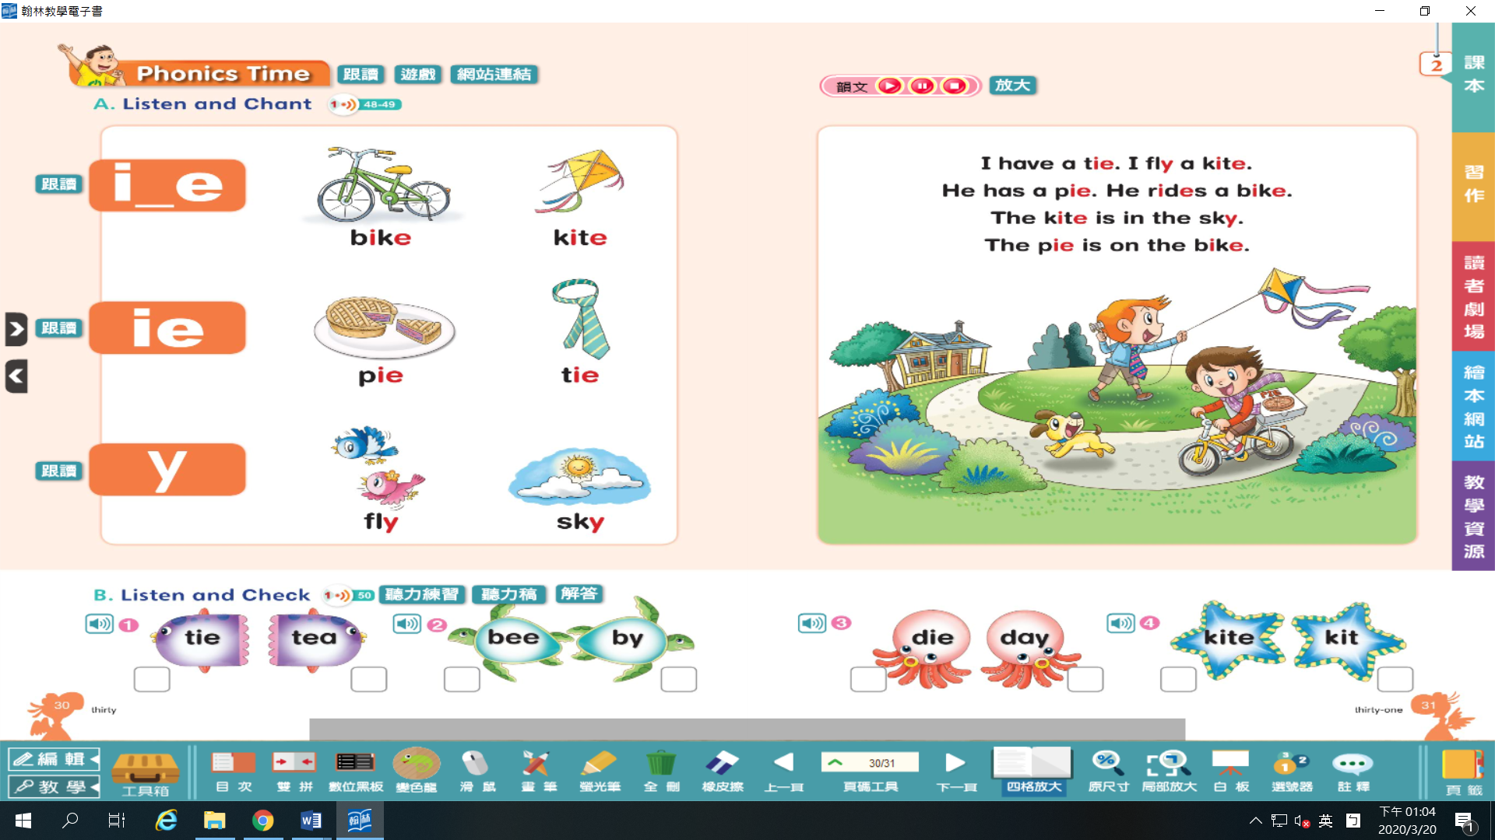

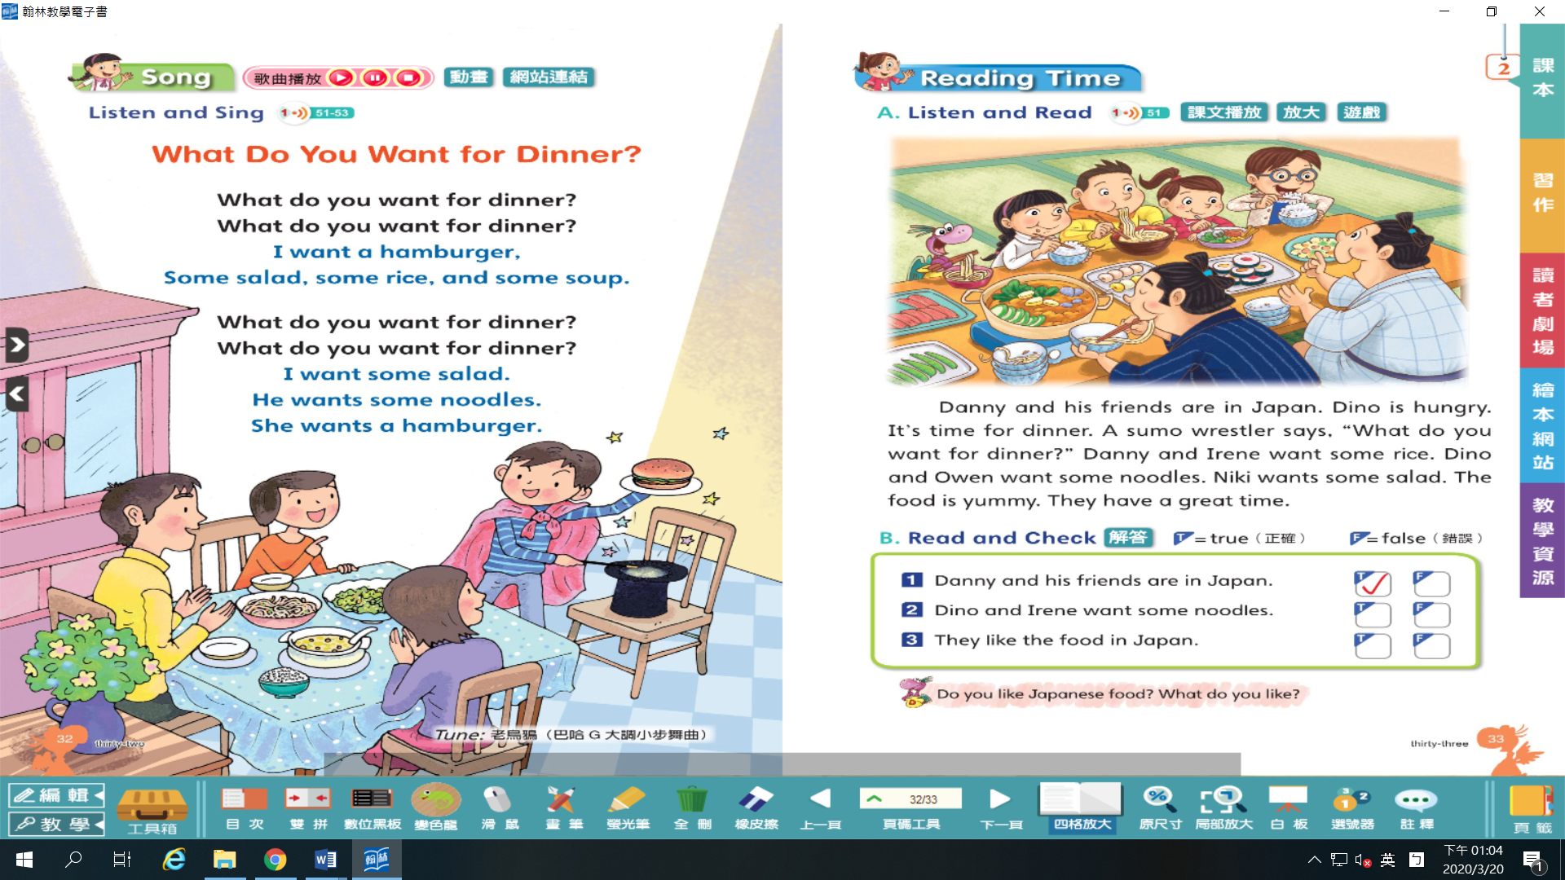
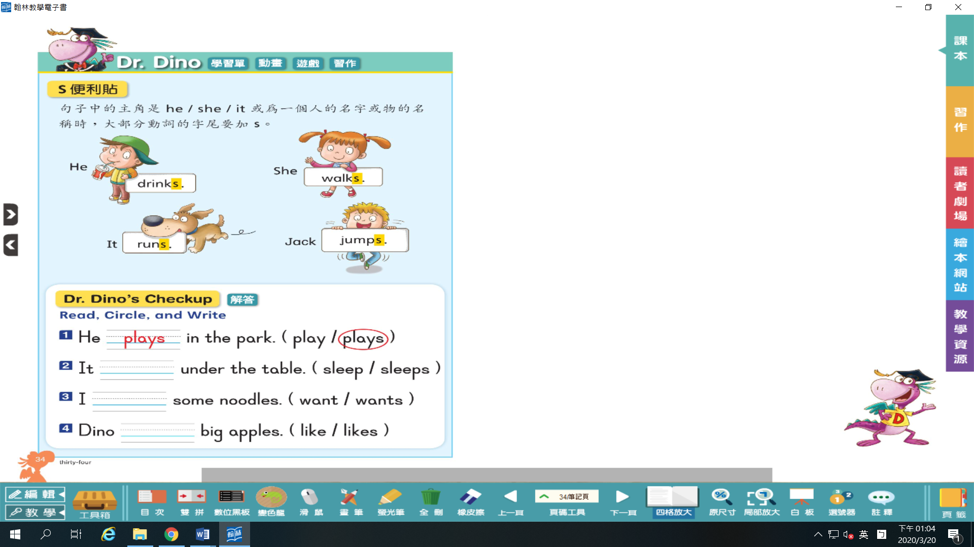滑鼠指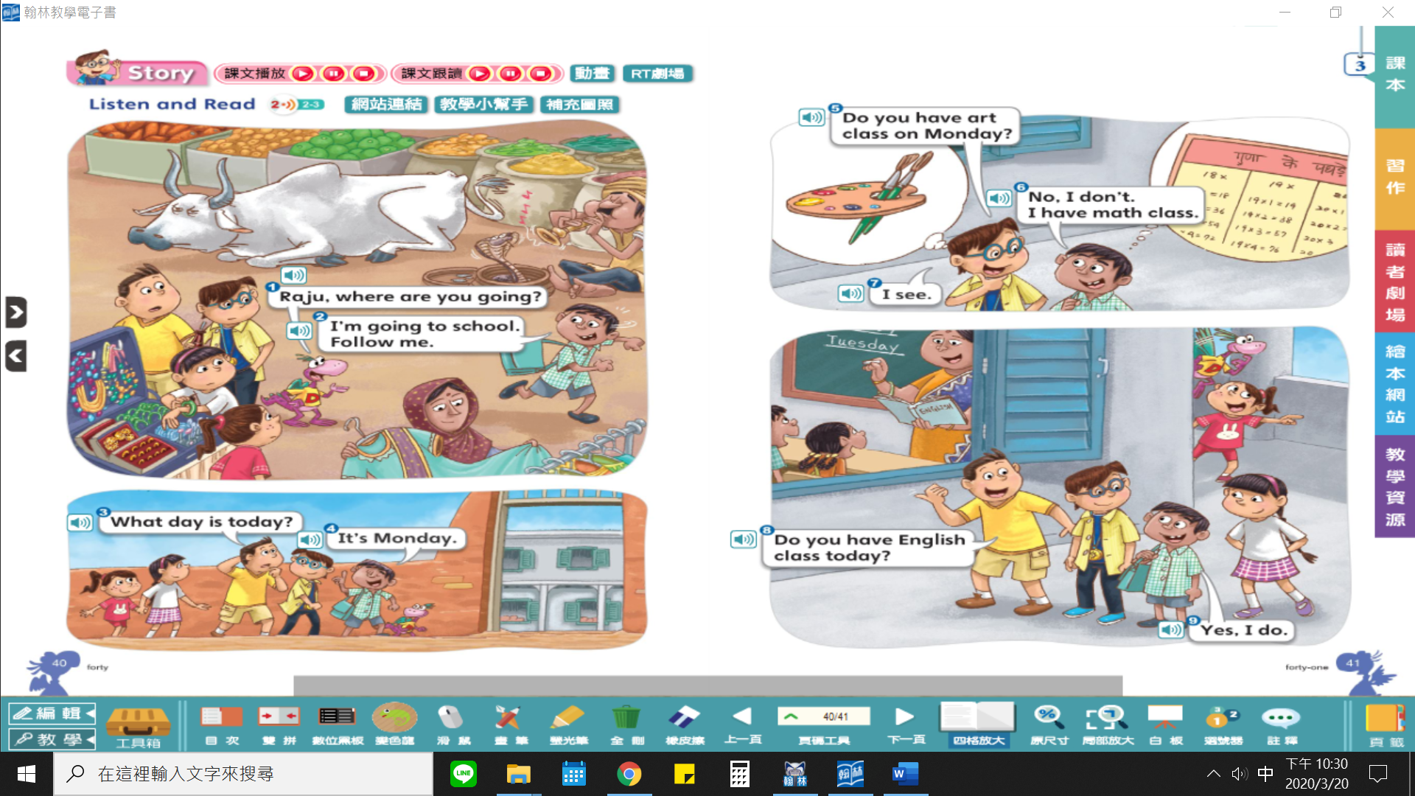
- Dino: Raju, where are you going?  - Raju: I’m going to school. Follow me.  - Owen: What day is today?  - Raju: It’s Monday.  - Danny: Do you have art class on Monday?  - Raju: No, I don’t. I have math class.  - Danny: I see.  - Owen: Do you have English class today?  - Raju: Yes, I do. | Dino: Raju，你要去哪裡？  Raju: 我要去上學。跟我來。  Owen: 今天是星期幾？  Raju: 今天星期一。  Danny: 你星期一有美術課嗎？  Raju: 不，我沒有。不過我有數學課。  Danny: 我懂了。  Owen: 你今天有英文課嗎？  Raju: 有的。
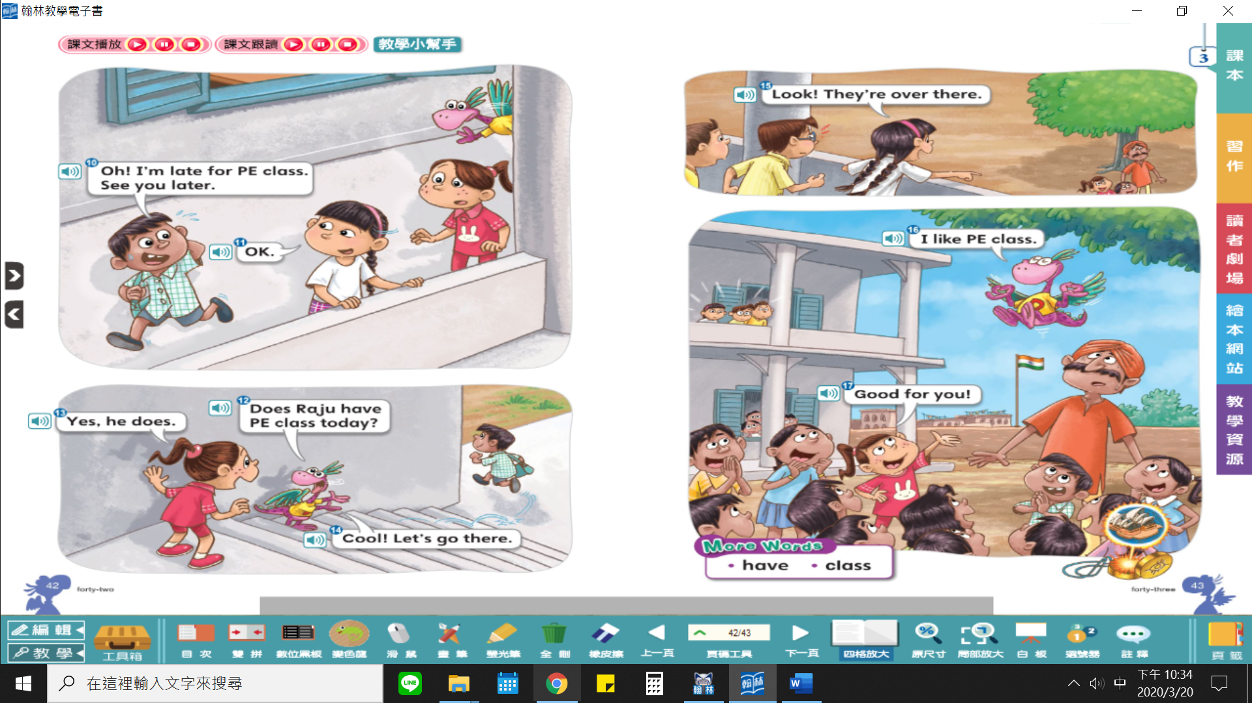
- Raju: Oh! I’m late for PE class. See you later.  - Irene: OK.  - Dino: Does Raju have PE class today?  - Niki: Yes, he does.  - Dino: Cool! Let’s go there.  - Irene: Look! They’re over there.  - Dino: I like PE class.  - Niki: Good for you! | Raju: 喔！我體育課遲到了。待會見。  Irene: 好的。  Dino: Raju 今天有體育課嗎？  Niki: 是的，他有。  Dino: 酷耶！我們去那邊。  Irene: 你們看！他們在那裡。  Dino: 我喜歡體育課。  Niki: 你真棒！
應用字彙
art 美術 Chinese 國語；中文 English 英語 math 數學 music 音樂 PE 體育
have /has 有（第三人稱單數時用） class 課 science 自然 social studies 社會

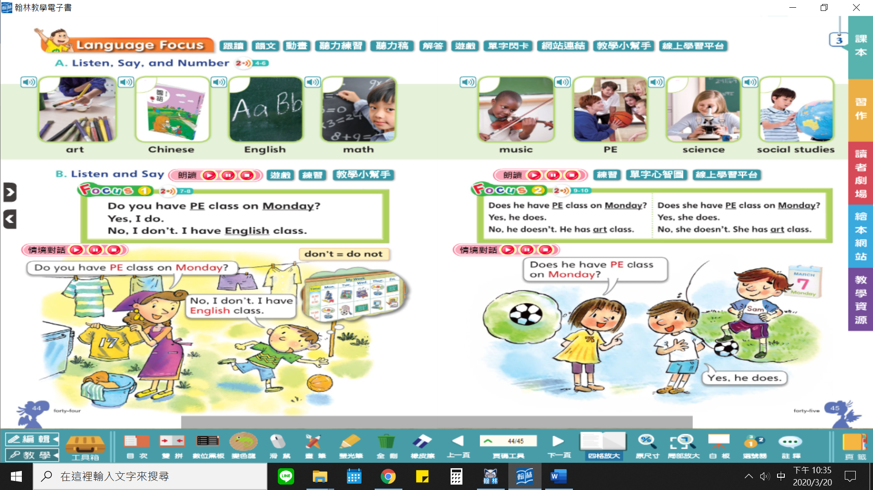

English | 中文
Sari | 紗麗
A sari is the traditional dress of Indian women. | 紗麗是印度女性的傳統服飾。
A sari is a long fabric.  There are many different ways to wrap a sari. | 紗麗是一塊長型布料。  纏繞包裹紗麗的方式變化繁多。
Sari means grace in India. | 在印度，紗麗是優雅的象徵。
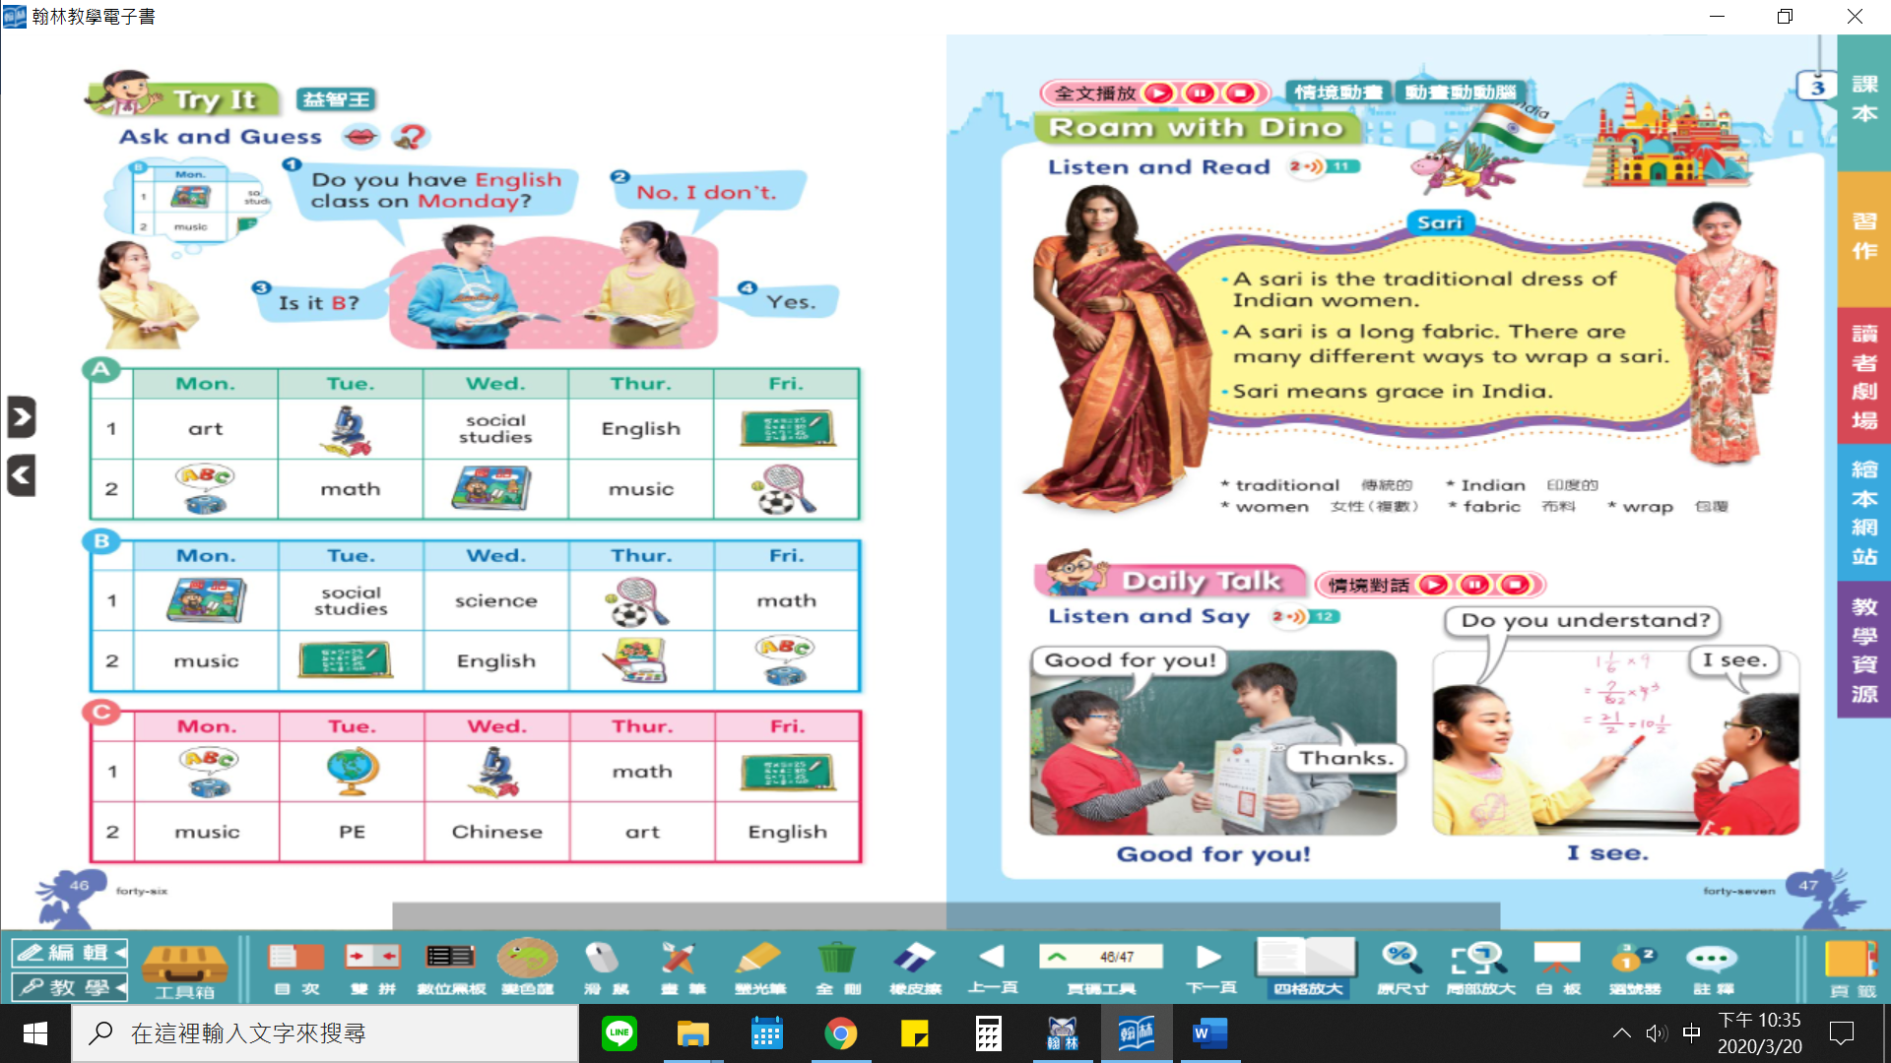

PHONICS 字彙
note 便條 rose 玫瑰花 boat 小船 goat 山羊 low 低的 row 划船
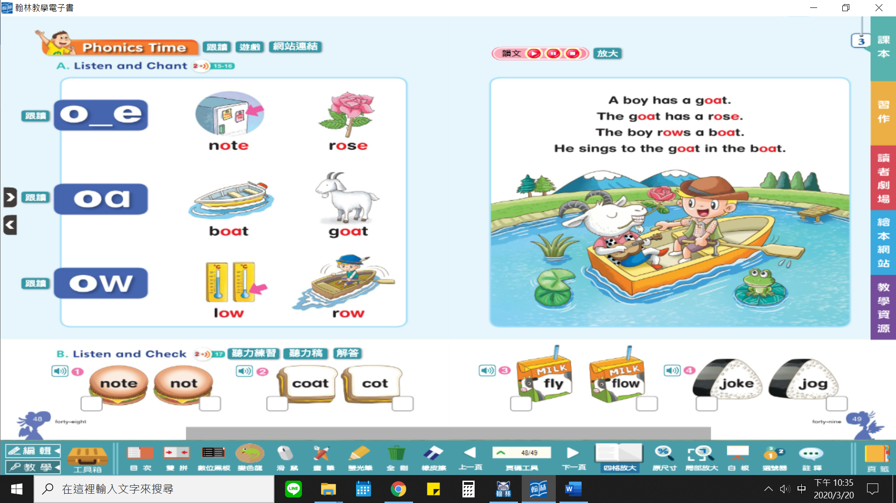

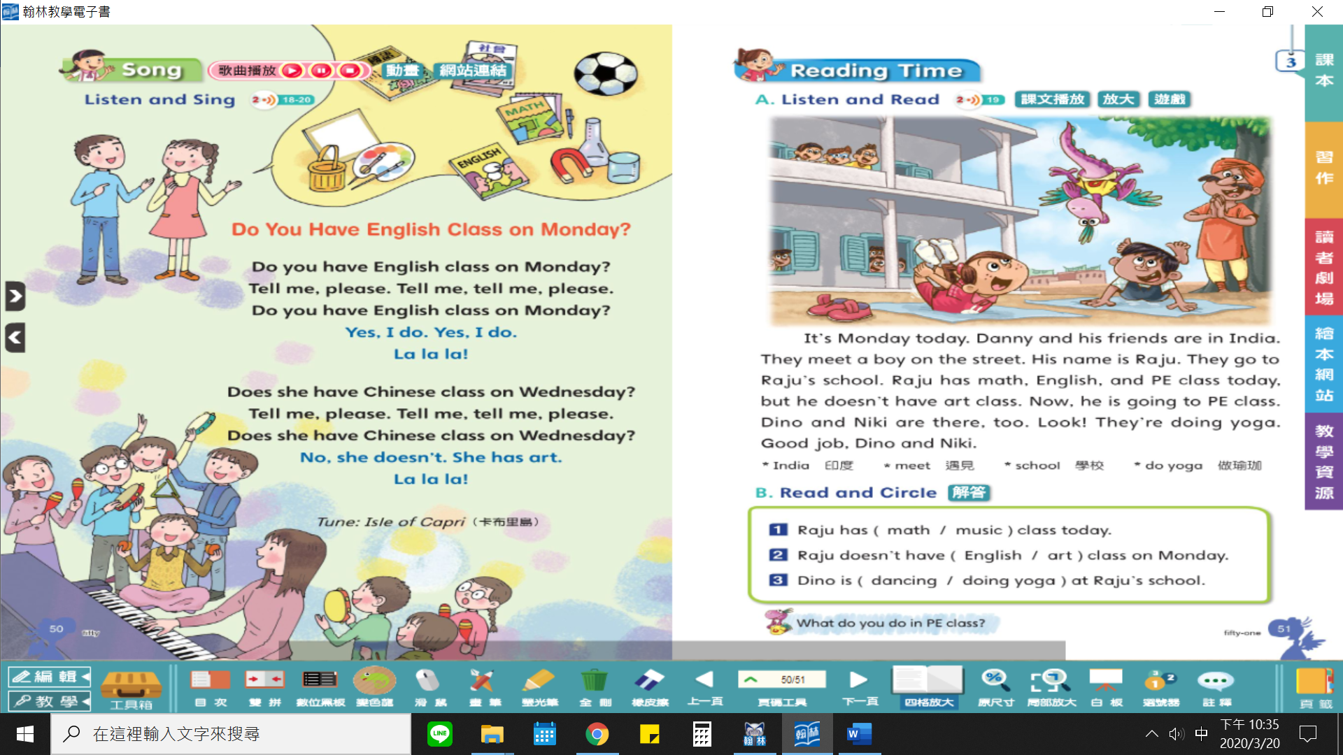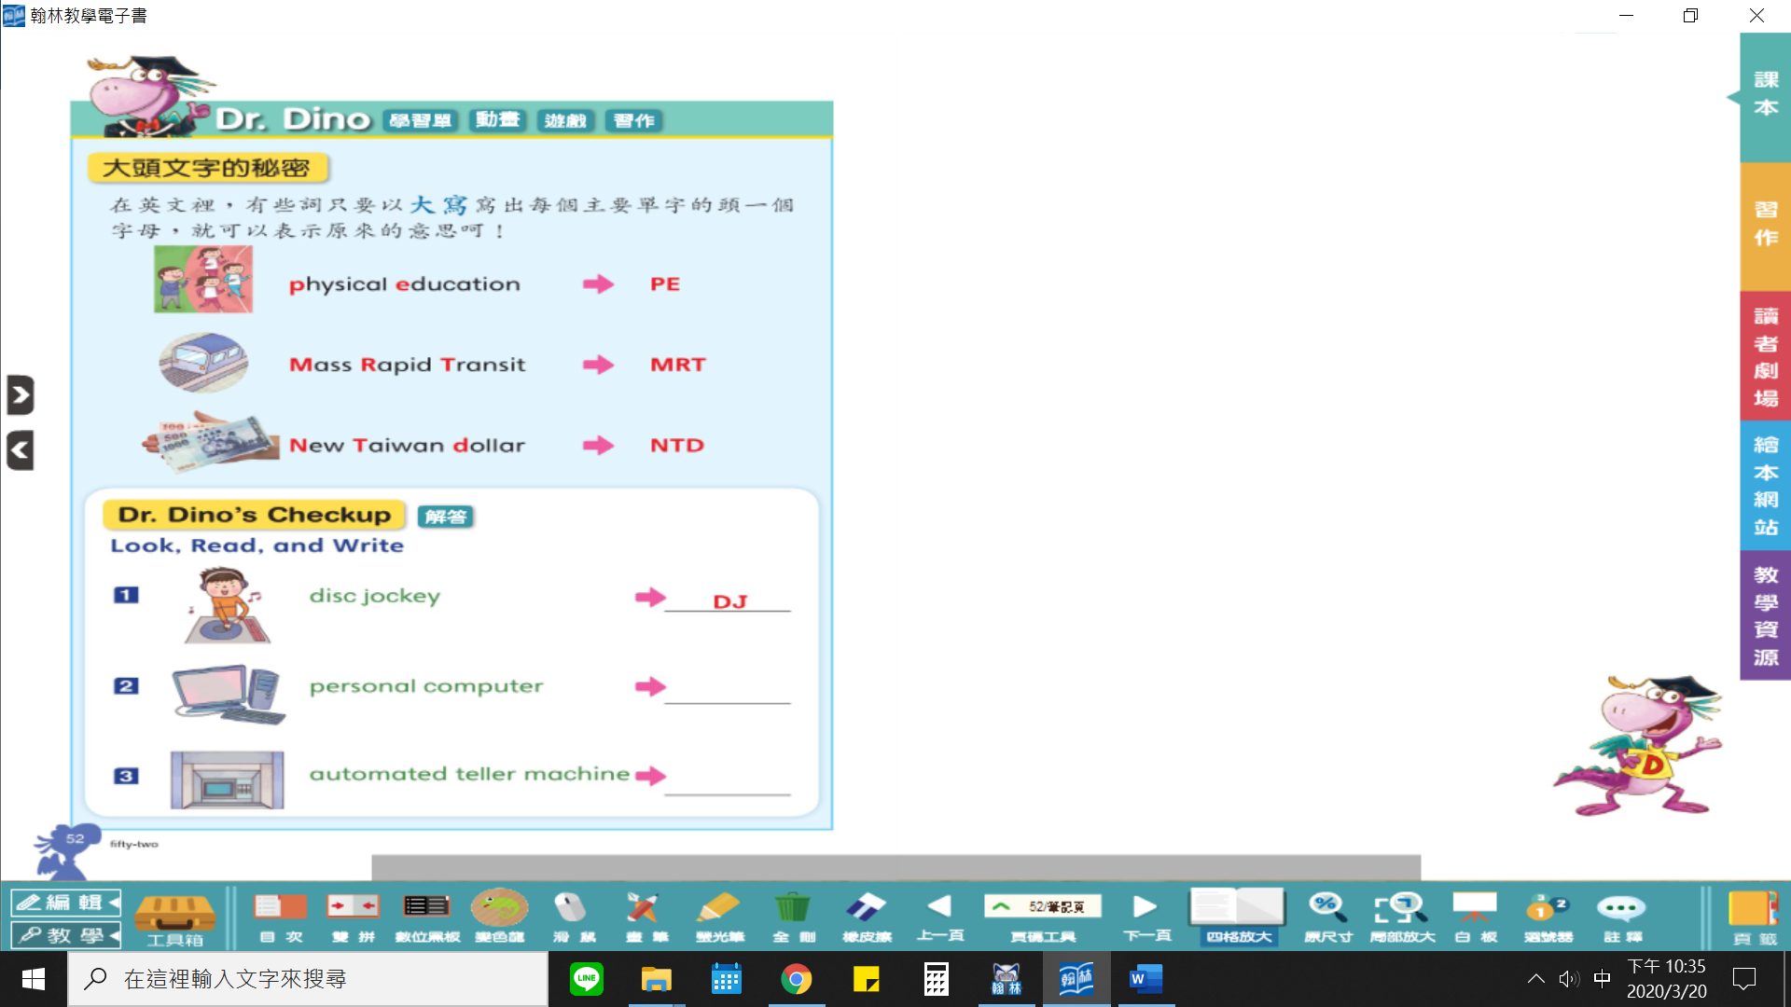

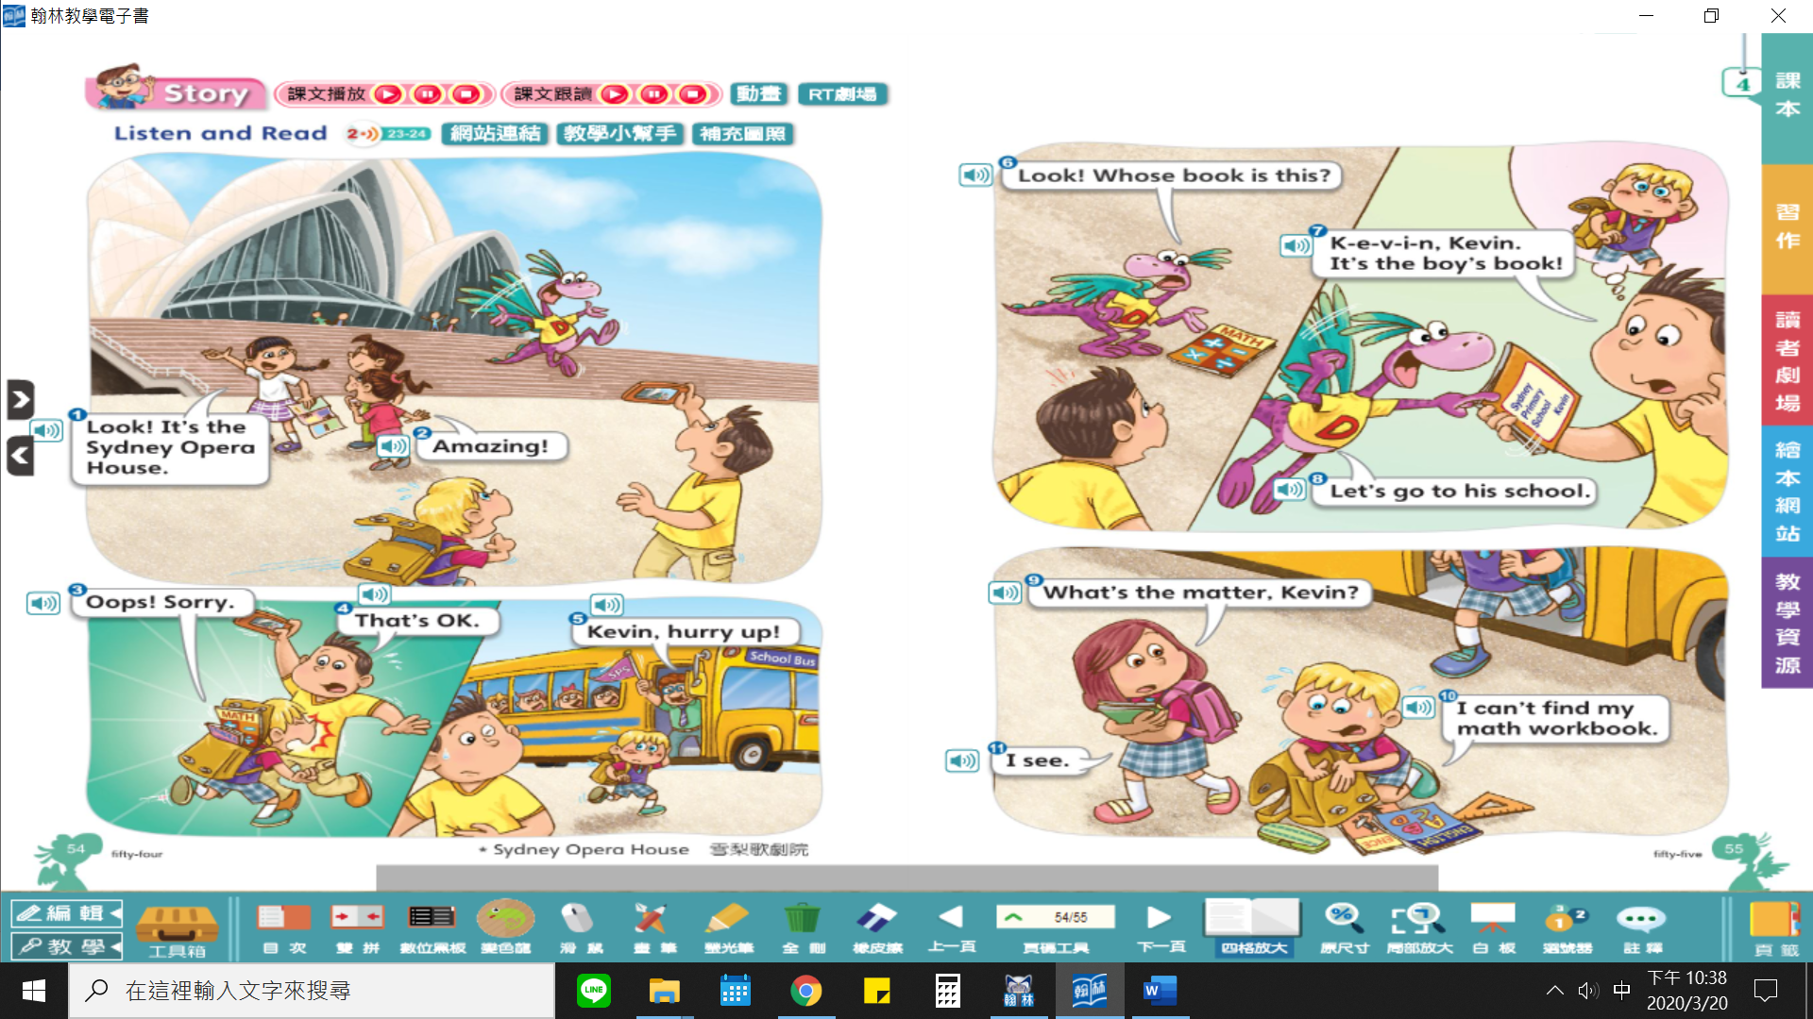
- Irene: Look! It’s the Sydney Opera House.  - Niki: Amazing!  - Kevin: Oops! Sorry.  - Owen: That’s OK.  - Kevin’s teacher: Kevin, hurry up!  - Dino: Look! Whose book is this? | Irene: 你們看！是雪梨歌劇院。  Niki: 好驚人喔！  Kevin: 哎喲！對不起。  Owen: 沒關係。  Kevin’s teacher: Kevin，動作快！  Dino: 你們看！這是誰的書呢？ | - Owen: K-e-v-i-n, Kevin. It’s the boy’s book!  - Dino: Let’s go to his school.  - Kevin’s classmate: What’s the matter, Kevin?  - Kevin: I can’t find my math workbook.  - Kevin’s classmate: I see. | Owen: K-e-v-i-n, Kevin. 是那位男孩的書！  Dino: 我們去他的學校吧。  Kevin’s classmate: Kevin，你怎麼了？  Kevin: 我找不到我的數學作業本。  Kevin’s classmate: 原來如此。

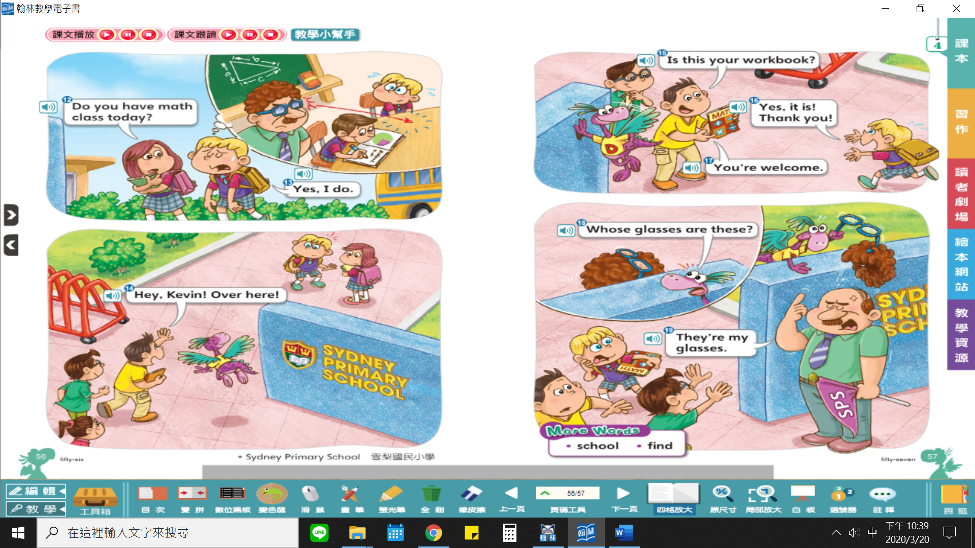
- Kevin’s classmate: Do you have math class today?  - Kevin: Yes, I do.  - Owen: Hey, Kevin! Over here!  - Owen: Is this your workbook?  - Kevin: Yes, it is! Thank you!  - Owen: You’re welcome.  - Dino: Whose glasses are these?  - Kevin’s teacher: They’re my glasses. | Kevin’s classmate: 你今天有數學課嗎？  Kevin: 有。  Owen: 嘿，Kevin！這邊！  Owen: 這是你的作業本嗎？  Kevin: 是的！謝謝你！  Owen: 不客氣。  Dino: 這是誰的眼鏡？  Kevin’s teacher: 是我的眼鏡。

應用字彙
cap 棒球帽 umbrella 雨傘 wallet 皮夾 workbook 作業本 glasses 眼鏡 glove(s) 手套（常用複數） sock(s) 襪子（常用複數） school 學校 find 尋找；找到 backpack 後背包

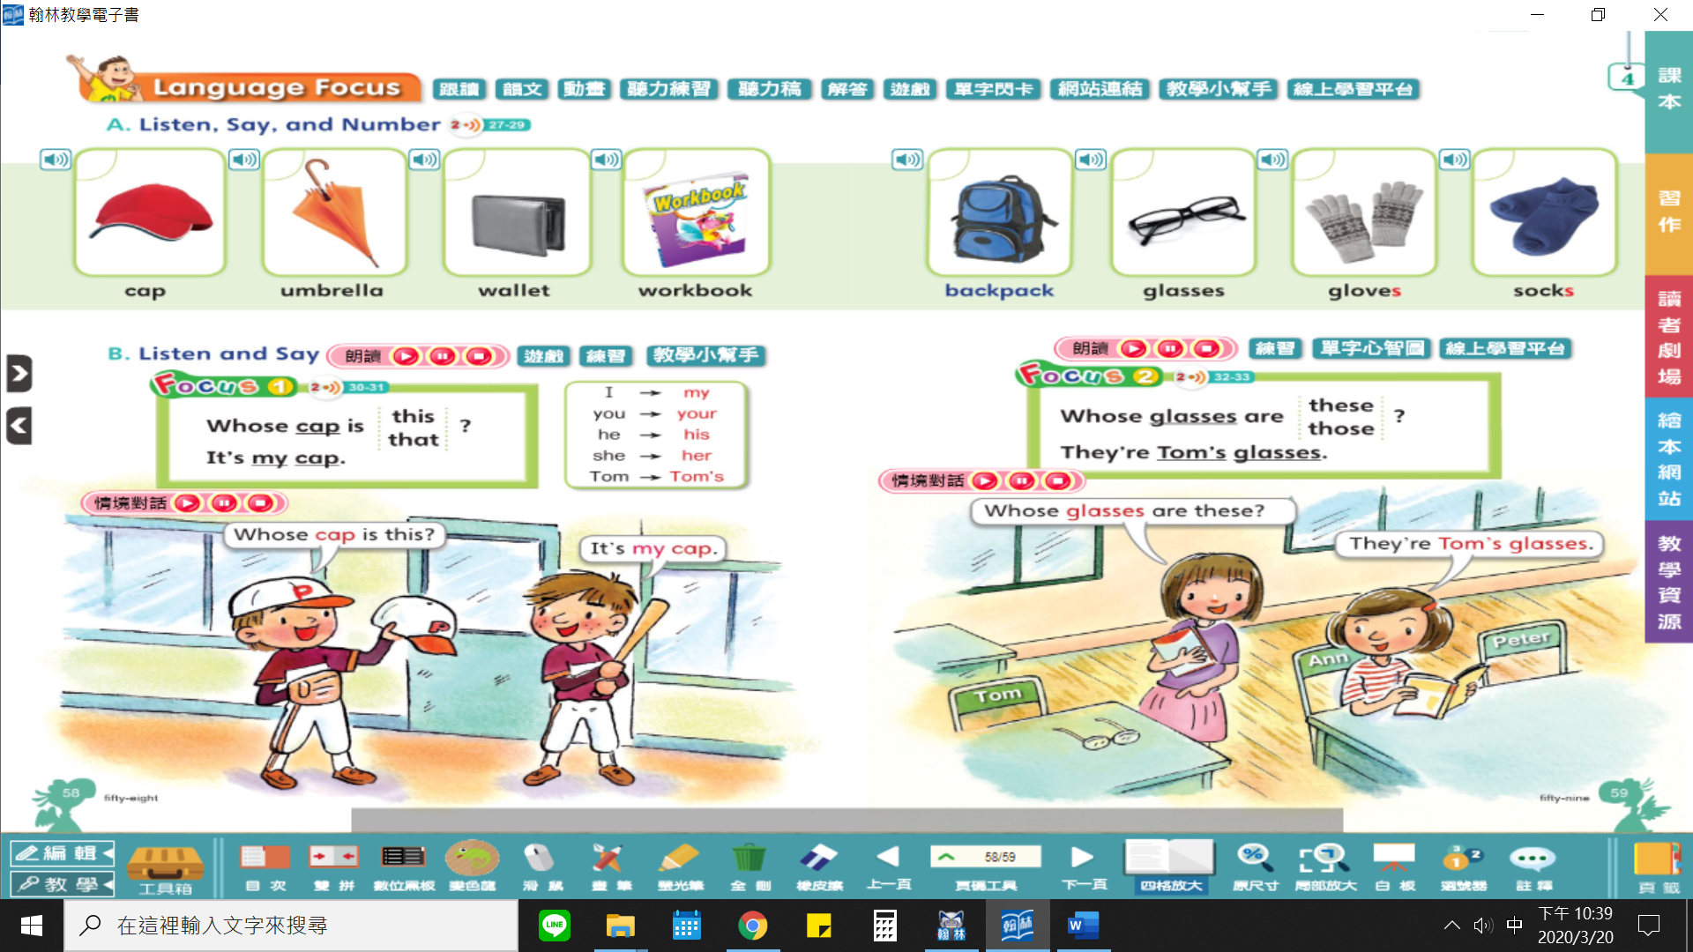

English | 中文
The Sydney Opera House | 雪梨歌劇院
The Sydney Opera House is a world-famous building in Australia.  Many people visit this place every year. | 澳洲的雪梨歌劇院是世界著名的建築。  每年有很多人慕名前來參觀。
Its roof looks like a peeling orange. | 他的屋頂就像剝開的柳橙。
People come to watch different shows here. | 人們都來這裡觀賞各式各樣的表演。
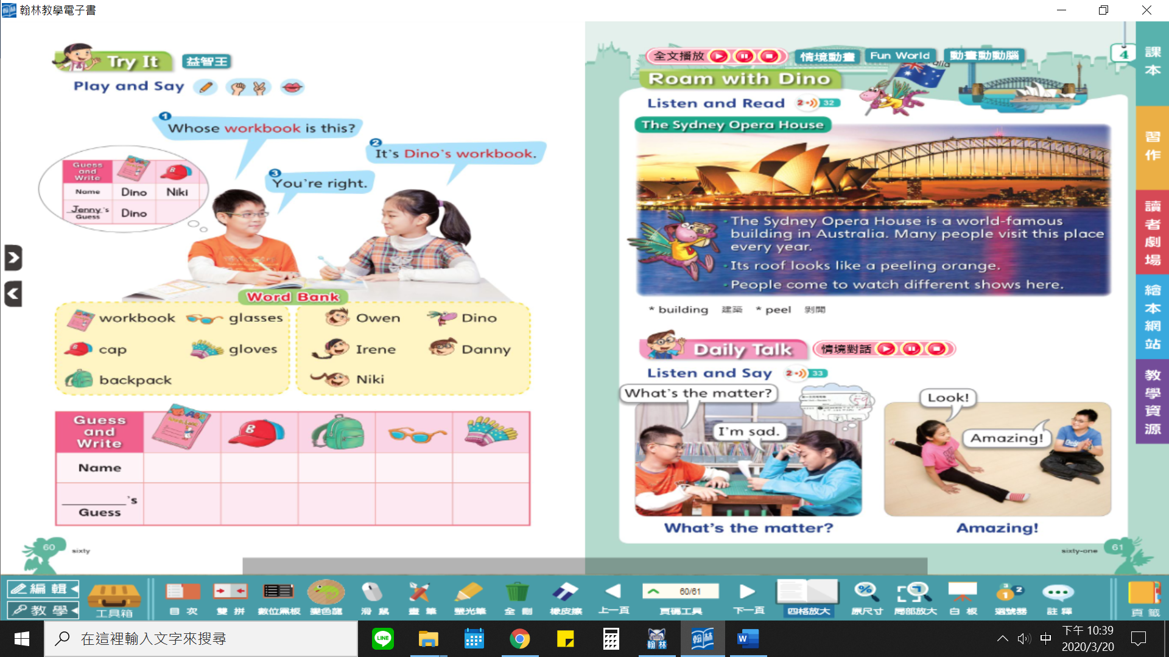

PHONICS 字彙
cute 可愛的 tube 軟管；管子 dew 露水 new 新的 fuel 加油；燃料 Tuesday 星期二
