Good afternoon, everyone.

How have you been? 你近來如何?

Do you feel bored at home?

在家會無聊嗎?



I don’t feel good

because I sprained my ankle.

老師不太舒服，因為腳扭傷了

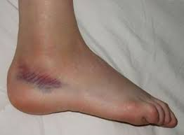

Now we will start our class.

It won’t last long. Let’s study together for 20 minutes.

現在開始上課了，我們共讀20分鐘就好

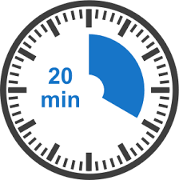

Who has a timer?

誰有計時器?

20分鐘到的時候，跟老師說

“Time’s up.(時間到)”



Now, please open your book and turn to page 47.

請翻到課本47頁。

First, we will review Lesson 3.

★可數名詞：通常是固體

★不可數名詞：通常是液體或氣體

(例如：湯、果汁、冰淇淋等)

★可數名詞：單數，前面加a/an

(例如：a hamburger, a sandwich,

a hot dog, an apple pie, an orange等)

★可數名詞：複數(二個或更多) ，字尾必須加s或es

(例如：hamburgers, sandwiches,

hot dogs, apple pies, oranges等)

現在請跟我唸課本47頁

a hamburger

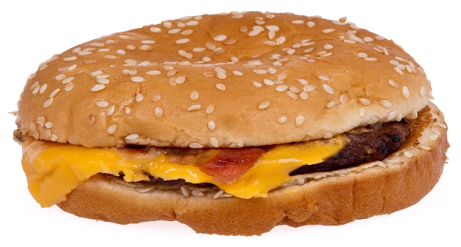

[此相片](https://vi.wikipedia.org/wiki/Hamburger) (作者: 未知的作者) 已透過 [CC BY-SA](https://creativecommons.org/licenses/by-sa/3.0/) 授權

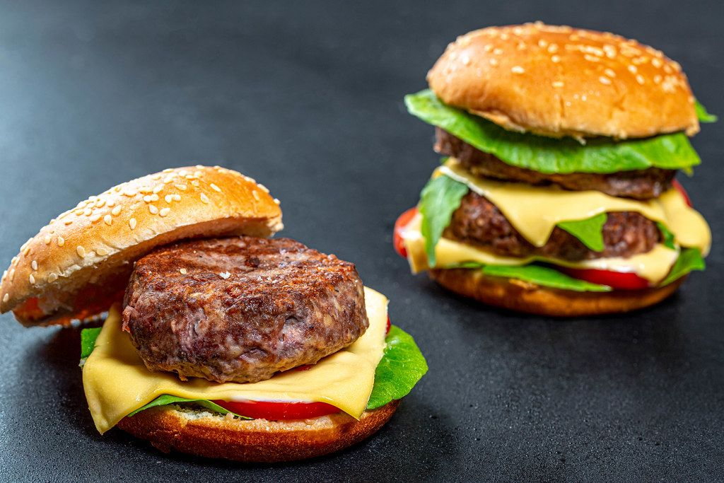 two hamburgers

(複數，字尾必須加s)

an apple pie

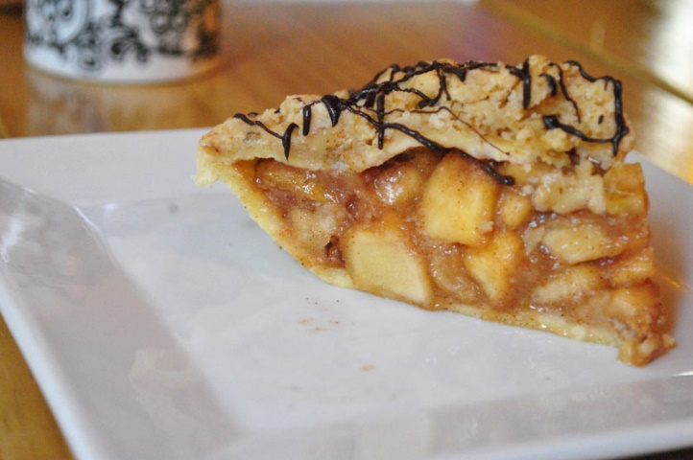

[此相片](https://commons.wikimedia.org/wiki/File:Creative_shot_apple_pie.jpg) (作者: 未知的作者) 已透過 [CC BY-SA](https://creativecommons.org/licenses/by-sa/3.0/) 授權

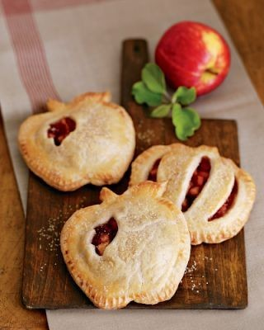

Three three apple pies

a sandwich

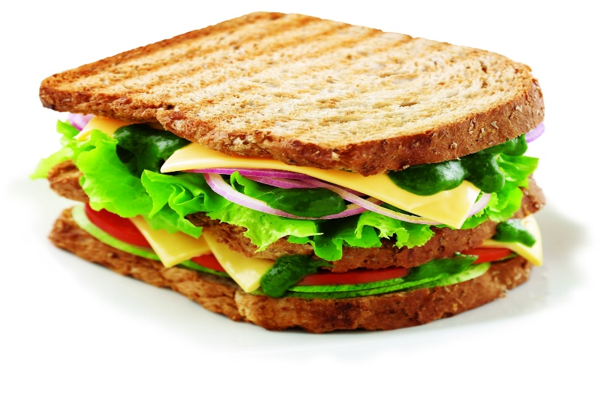

[此相片](http://www.foodista.com/recipe/88MPNWLK/schezwan-sandwich) (作者: 未知的作者) 已透過 [CC BY](https://creativecommons.org/licenses/by/3.0/) 授權

four(4) sandwiches

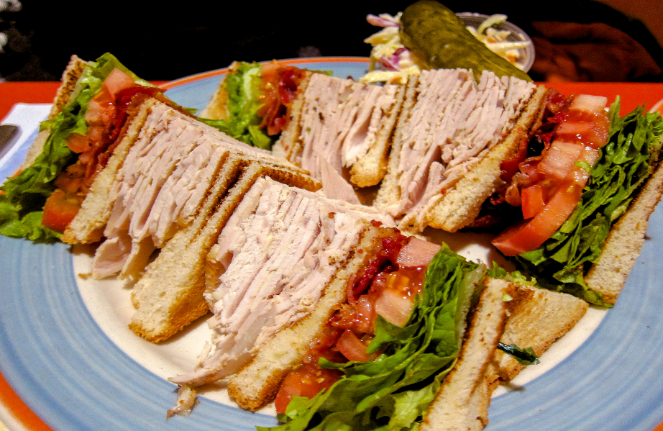

[此相片](https://en.wikipedia.org/wiki/Club_sandwich) (作者: 未知的作者) 已透過 [CC BY-SA](https://creativecommons.org/licenses/by-sa/3.0/) 授權

★不可數名詞：通常是液體或氣體

(例如：湯、果汁、冰淇淋等)

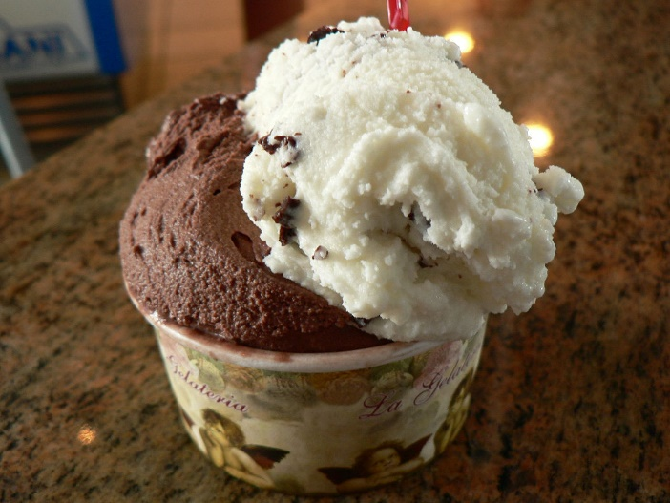 ice cream (前不可加a/an；後不可加s/es；soup

也是相同規則

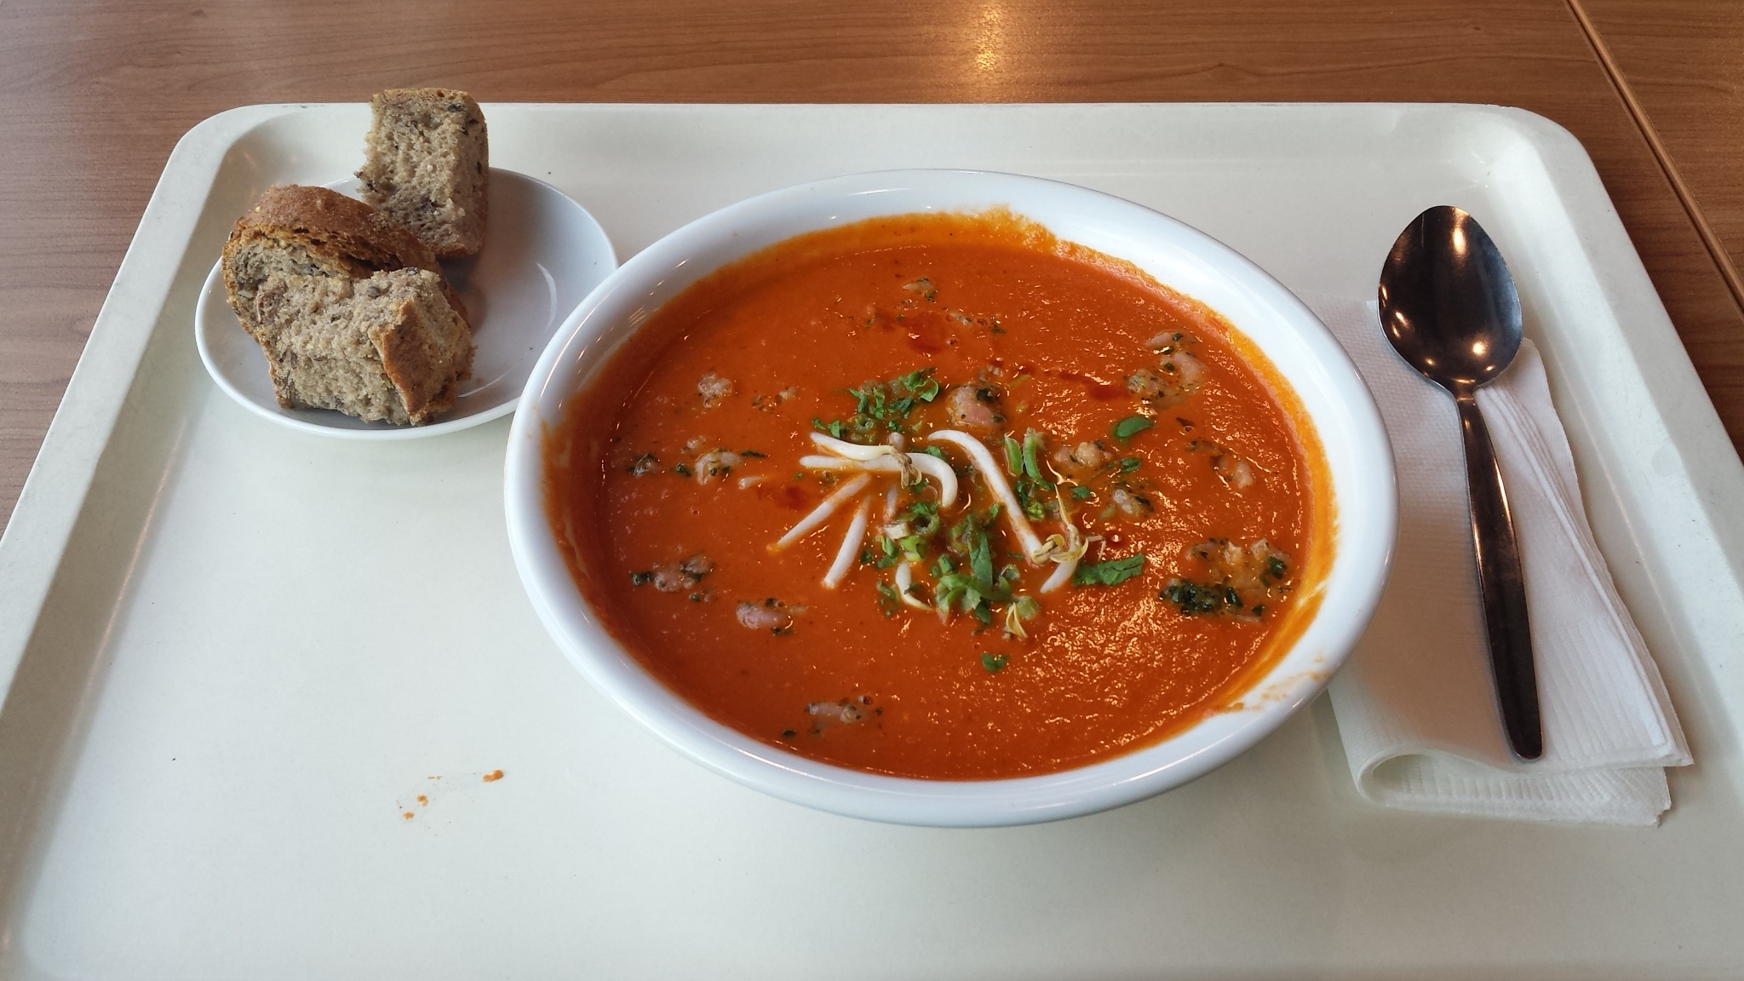

Please turn to page 43.

請翻到43頁。

Repeat after me. (請跟我唸!)

1. I’m hungry. 我肚子餓
2. Me, too. 我也是
3. I want a hamburger. What do you want to eat?

我想要吃一個漢堡。你想吃什麼?

1. I want a sandwich and an apple pie.

我想吃一個三明治和蘋果派

1. How about you, Kevin?

Kevin、那你呢?

1. I want a hamburger and soup.

我要一個漢堡和湯

1. I want a hot dog.

我要一個熱狗

1. A hot dog?

一個熱狗?

1. What do you want to eat, Toby?

Toby、你想吃什麼?

1. I want ice cream.

我要吃冰淇淋

1. OK. An apple pie, a hot dog, two hamburgers…..

好、一個蘋果派、一個熱狗、

兩個漢堡

1. A sandwich, soup, and ice cream.

一個三明治、湯和冰淇淋

1. Here you are.

你要的東西在這裡

1. Thank you.

謝謝你

1. I’m hungry.

我肚子餓

1. Oh, no! My ice cream.

糟了！我的冰淇淋