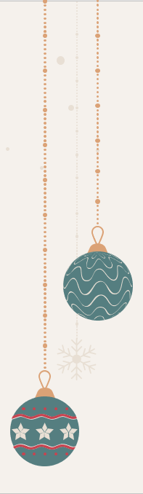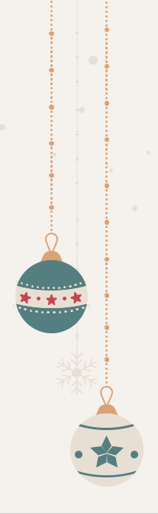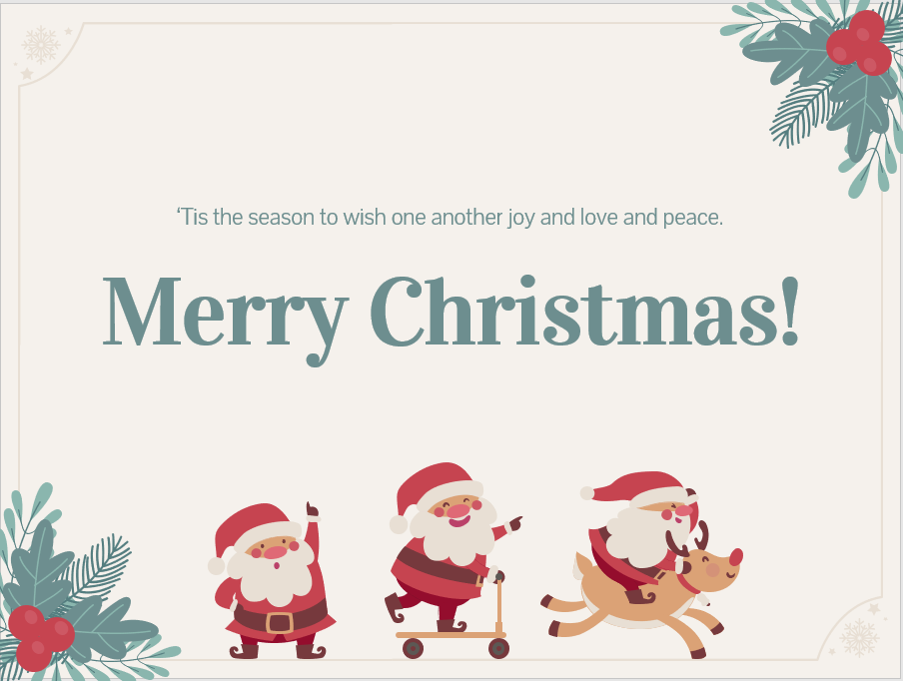

Dear Santa Claus,

My name is_________(English name & Family name). I am _______ years old. I study in Liouying Junior High School in Taiwan. I like to _________________________________and _____________

________________________________in my free time. Besides, my favorite _________ is _______________________________. My my favorite _________ is _______________________________. In the future, I want to be a ______ because__________________________

__________.

This year, I have been a good _____(boy/girl). This Christmas, could I have ________________? Thank you so much! I can’t wait to receive your letter!

Sincerely,

______(English name & Family name)