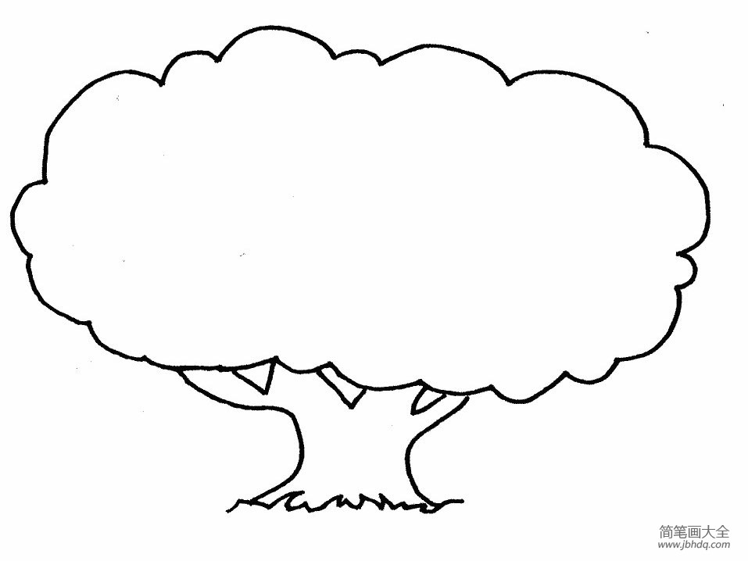

**_____’s Family Tree**

**Class: Number: Name:**

**Family Tree**