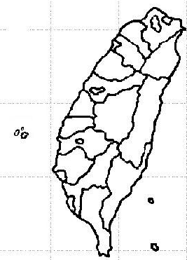 

* How is the weather?

The weather is __________________________________________________

* Who do you go with?

I go with ______________________________________________________

* How do you get there?

I go there ______________________________________________________

Attraction

* What do you see?

I see _________________________________________________________

* What do you eat?

I eat _________________________________________________________

* What is the highlight?

The highlight is that _____________________________________________