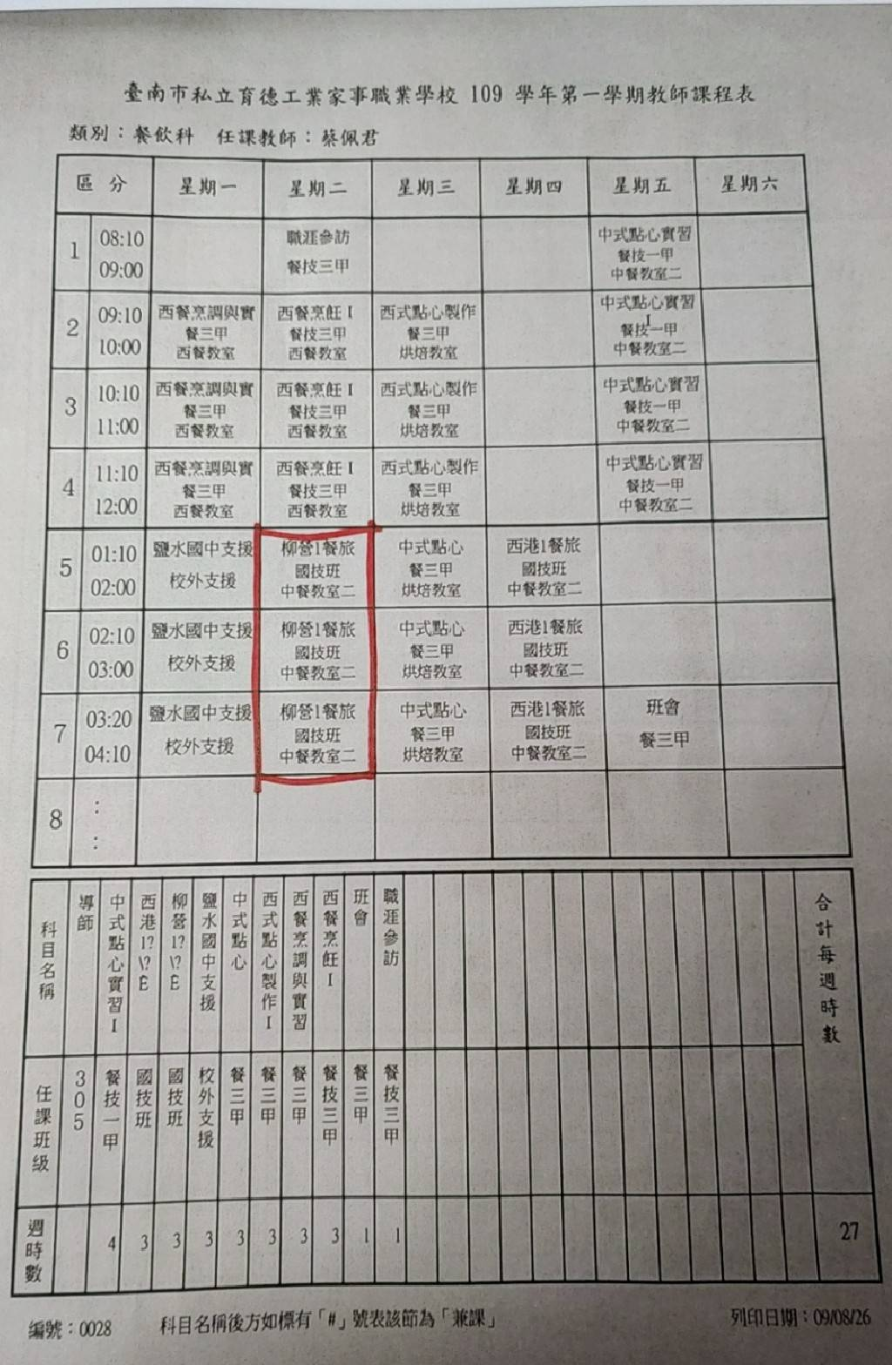

|  |  |
| --- | --- |
| **柳營國中技藝教育課程學習照片** | |
|  |  |
|  |  |
|  |  |