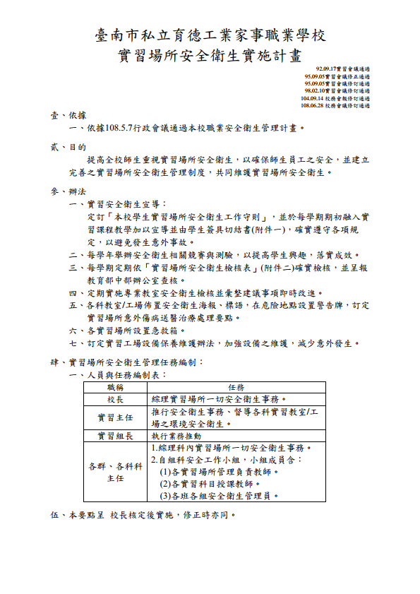

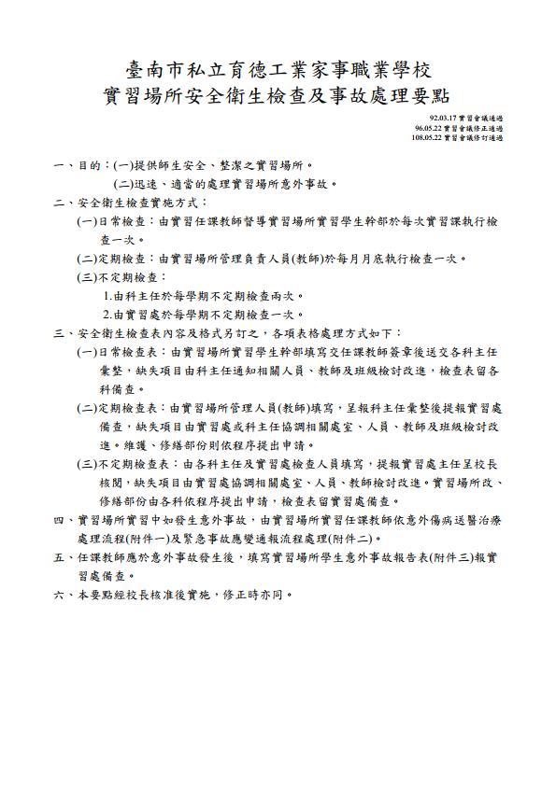

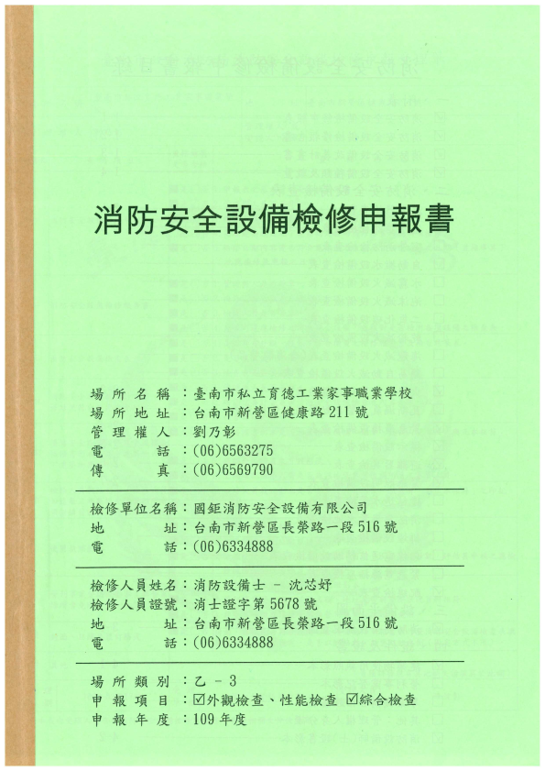

|  |
| --- |
|  |
|  |
|  |
|  |
|  |
|  |

餐飲科實習專業教室

配置圖

教室名稱：西餐教室

|  |
| --- |
| 電源箱  10  4  9  3  11  5  12  6  8  2  7  1  **門**  **口**  **門**  **口**  冰 箱  冰 箱  儲 藏 室 |

教室名稱：烘焙教室

|  |  |  |  |  |  |  |  |  |  |  |  |  |  |  |  |  |  |  |  |  |  |  |  |  |  |  |  |  |  |  |  |  |  |  |  |  |  |  |  |  |
| --- | --- | --- | --- | --- | --- | --- | --- | --- | --- | --- | --- | --- | --- | --- | --- | --- | --- | --- | --- | --- | --- | --- | --- | --- | --- | --- | --- | --- | --- | --- | --- | --- | --- | --- | --- | --- | --- | --- | --- | --- |
| |  |  |  |  |  | | --- | --- | --- | --- | --- | |  | 12 | | 11 | | |  | 9 | | 10 | | |  |  | |  | | |  | 8 | | 7 | | |  | 5 | | 6 | | |  |  | | |  | | 4 | | 3 | |  | | 1 | | 2 | |  |   白 板  材 料 室  器 具 室  烤 箱  冷凍冰箱  烤 箱  烤 箱  發酵箱  發酵箱  烤 箱  發酵箱  烤 箱  發酵箱  烤 箱  電源箱  **門 口**  **門**  **口**  急速冷凍  冷藏 |

教室名稱：中餐教室一

|  |
| --- |
| 11  5  12  6  **門**  **口**  電源箱  冰 箱  門  10  4  9  3  8  2  7  1  **門**  **口**  白板 |

教室名稱：中餐教室二

|  |
| --- |
| 發酵箱  冰箱  烤箱  烤箱  烤箱  電源箱  2  7  1  8  **門**  **口**  **門**  **口**  4  9  3  10  11  5  12  6  發酵箱  烤箱  烤箱  烤箱  門 |

教室名稱：飲調教室

|  |
| --- |
| 白 板  **門**  **口**  **門**  **口**  **門**  **口** |

汽車修護設備配置圖

西

北

南

東

