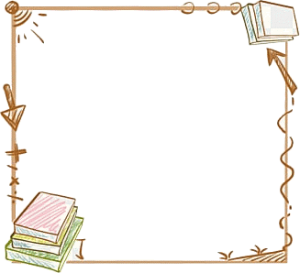臺南市麻豆區麻豆國民小學

閱讀學習單

|  |  |
| --- | --- |
| 書名： | 作者： |
| 出版社： | 出版年月： |
| 書籍來源： | 布可星球書單：是□ 不是□ |

§閱讀心得§

〈心得字數不得低於200字，位置不夠可寫在背面〉

________________________________________________________________________________________________________________________________________

________________________________________________________________________________________________________________________________________

________________________________________________________________________________________________________________________________________

________________________________________________________________________________________________________________________________________

________________________________________________________________________________________________________________________________________

________________________________________________________________________________________________________________________________________

____________________________________________________________________ ____________________________________________________________________

________________________________________________________________________________________________________________________________________

____________________________________________________________________

§名言佳句§

〈請找出書籍中的名言佳句或成語，查詢解釋記錄下來，最少五個〉________________________________________________________________________________________________________________________________________

________________________________________________________________________________________________________________________________________

____________________________________________________________________