5/1(五)九點準時線上直播抽籤，網址及QRcord如下：

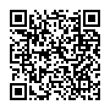https://www.youtube.com/channel/UC7lXEHy2cD7O1WMn2fHtFA?view_as=subscriber